

Personal Lines

Workflows & Procedures

*for*

**Acrisure** **NJ Partners Insurance Services, LLC**

V3.28.25



# EPIC BASICS

## How to Use this Document

This document contains valuable information relevant to your usage of EPIC, including **Epic Basics**, day-to-day **Workflows**, and **Job Aids. DO NOT PRINT THIS DOCUMENT.**

For optimal usage:

* Click the **View** menu at the top in the Microsoft Word toolbar
* Checkmark **Navigation Pane**

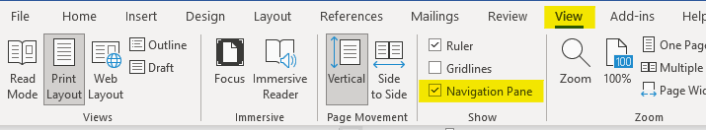

* The left pane will open and show a listing of topics

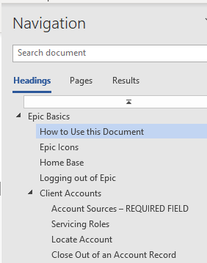

* Click on the topic to jump to that section/page.
* You will also find hyperlinks within the document that will take you to a specific page or Job Aid.

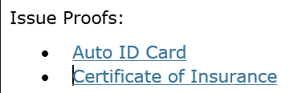

* Some hyperlinks will take you to a webpage outside of the document.

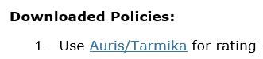

## Epic Icons

|  |  |  |  |
| --- | --- | --- | --- |
|  | Add New |  | Change column width |
|  | Edit |  | To define a search |
|  | Print list view |  | Executes search. These are cumulative. To begin a new search, click “Clear Filter” |
|  | Sortable column – ascending/descending |  | The logout button will close all open windows. If any screen requires validation (the process isn’t complete), the screen with display prior to closing |
|  | Change the order of items | **RIGHT CLICK** | Right clicking from a selected will often generate the same menu as ACTIONS. |
|  | Collapses and opens sections of screen or moves full list from one screen to another |  | Click on the Paperclip to attach documents saved in Epic (Email) |
|  | Required Field – must complete |  | Click on the File to attach files saved on a local or network drive (Email) |
|  | Desired Field – agency would like field completed |  | Contacts in EPIC (from email) |
|  | Customize columns displayed in the list view |  | Contacts in Outlook (from email) |

## Home Base

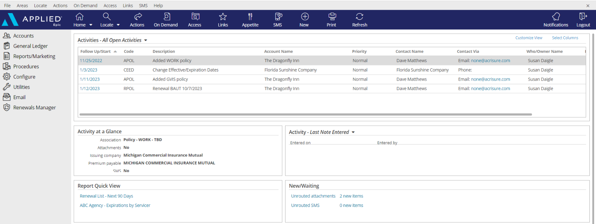

|  |
| --- |
| 1. **Open Activities** (suspense, follow up, to-do list)    * Use “Select Columns” to add columns to your view.    * You can also change the position of the columns by clicking and dragging the column headers to move them.    * Sort columns in ascending or descending order by clicking on the column header 2. **Activity at a Glance** – displays information about the highlighted activity 3. **Activity Tasks** OR **Last Note Entered** – if you are assigned a task within an activity the task will appear here only if the activity above, associated with the task, is highlighted. You can change the view from “Activity – Tasks” to “Last Note Entered” by clicking the dropdown arrow and selecting that option. 4. **Report Quick View** – Created reports can be sent to Report Quick View for easy access. Just click the link and the report will open. Data displayed is in real time and will be refreshed as of the date it is opened 5. **New/Waiting** – If your agency has opted to use Front End Scanning, your scanned mail can be accessed by clicking the “Unrouted Attachments” link. The number of items in your “inbox” will also display. 6. **Navigation Panel** – Items listed will direct you to different parts of Epic or the client’s account if you are on the locate screen or within the client account. Items listed change depending on which screen you’re on. This is known as the “View” panel. 7. **Blue Options Bar** – Each icon contains action options, which change depending on which screen you’re on. Think of this as the “Do” bar. 8. **Log Out button** – Clicking this button will close all the open screens/windows and log you out of Epic. 9. **Locate** – Click the dropdown arrow to see list of last 20 accounts accessed |

## Keyboard Shortcuts

|  |
| --- |
|  |

## Epic Browser

### Logging In

|  |
| --- |
| 1. Open a web browser    1. Chrome    2. Edge 2. Enter URL:    1. Production/Live: <https://acris03.appliedepic.com/#/> 3. b. Test/Training: https://ve061t1web.appliedepic.com/#/ |

### Add the URL as a bookmark in the Chrome or Edge Browser

|  |  |  |
| --- | --- | --- |
| 1. In the browser URL address field, enter <https://acris03.appliedepic.com/#/>; press the keyboard enter key 2. Add to Bookmarks/Favorites as follows:  |  |  | | --- | --- | | **CHROME**    Click the star icon  Enter a name for the bookmark; click Done | **EDGE**    Click the star icon  Enter name and add to Favorites Bar; click Done | |

### Browser Tabs

|  |
| --- |
| Browser tabs will open at the top when accounts are located and selected    Use browser tools like Tab Grouping and Zoom, if desired.  To prevent connection issues, close out of a client by clicking the X above the Logout button, NOT the x in the browser tab |

### Connection Suite & New Functionality Popups

|  |
| --- |
| The Connection Suite is required to ensure full functionality and connection within Epic Browser. Acrisure IT manages all updates in the background for the Connection Suite Plugin. **Ignore these popups.** If you are receiving an error, follow the instructions to hard shutdown to ensure there’s a clean connection to all services run on your computer. If you are experiencing functionality issues after shutting down, submit a ticket to [support@acrisure.com](mailto:support@acrisure.com).  ***Reminder: A hard shut down of your computer should be done at the end of each workday.*** |

### Logging out of Epic

|  |
| --- |
| **\*\*IMPORTANT\*\***  Whenever you **close out of Epic,** be sure to click the LOGOUT button at the top right in the blue Options Bar. Do not X out or Epic will not close properly and may cause issues when signing in again.  **NO** |

### Shutting Down Desktop

|  |  |  |  |  |  |  |
| --- | --- | --- | --- | --- | --- | --- |
| **\*\*IMPORTANT\*\***  Log out of Epic and SHUT DOWN your computer **at the end of each workday.**   |  |  | | --- | --- | | Shut down the computer by clicking the Start Menu in the bottom left-hand corner of your desktop |  | | Click Power |  | | Click Shut Down |  | |

## Client Accounts

### Account Sources – REQUIRED FIELD

|  |  |
| --- | --- |
| 0. Cross Sell-Platform | **Account Source is a Required Field.**  **Be sure to select the appropriate one for tracking and reporting purposes.**  If you do not know the policy source, select “**Update Needed**” so it can be updated when known. |
| 1. AM/AE Solicited |
| 1. Producer Solicited |
| 2. Referral - Acrisure Cyber Services |
| 2. Referral - Acrisure Title Partner |
| 2. Referral - Association |
| 2. Referral - Broker - Acrisure |
| 2. Referral - Broker - Non-Acrisure |
| 2. Referral - Client |
| 2. Referral - Employee |
| 2. Referral - Financial Partner/WM |
| 2. Referral - Franchisor |
| 2. Referral - GA |
| 2. Referral - Other |
| 2. Referral - Payroll Firm |
| 2. Referral - TPA |
| 3. Marketing - Acrisure.com |
| 3. Marketing - Other |
| 3. Marketing - Telemarketing |
| 4. Other/Unknown |
| 5. Win Back |
| 6. Call In/Walk In |
| Z. AMS Conversion - Unknown |
| Z. Epic Import |
| Z. Update Needed |

For more details as how to use each source code, refer to the Epic Source Codes cheat sheet found on the [NJ Platform SharePoint](https://acrisure.sharepoint.com/:x:/r/sites/AcriWorld/Shared%20Documents/Enterprise_Solutions_Center/Platforms/New_Jersey/Epic,%20CSR24%20%26%20Indio%20Resources/Epic%20-%20Quick%20Guides,%20Cheat%20Sheets%20%26%20Training%20Videos/Epic%20Source%20Codes%20Cheat%20Sheet.xlsx?d=wb58cf5bca92849b9afa09f91065fa2ac&csf=1&web=1&e=t9P8OM).

### Servicing Roles

|  |  |  |  |  |  |  |  |
| --- | --- | --- | --- | --- | --- | --- | --- |
| **External Service Team** | |  | | --- | | Acrisure Service Center | | Carrier Service Center | | GA - Emerson Reid | | GA - Martin Insurance Services * | | GA - PGM * | | GA - Suvaun * |   **When an account and/or policy is managed by an external service team (the Acrisure Service Center, a Carrier Service Center, or a General Agent on the EB side), select the appropriate one from the drop-down list.**  **Note:**  **An Acrisure-owned GA will be indicated by an asterisk.** |
| Marketing |
| P&C Primary Producer |
| P&C Servicing Producer |
| P&C Account Manager |
| P&C Other Account Manager |
| P&C Claims |
| CL Account Executive |
| Surety Primary Producer |
| Surety Account Manager |
| EB Primary Producer |
| EB Servicing Producer |
| EB Account Manager |
| EB Other Account Manager |
| Other |
| Non-Insurance Product Producer |
| FS Primary Producer |
| FS Account Manager |

### Locate Account

|  |
| --- |
| * Click the **Locate** button to **search** for existing clients   **Locate Options:**   * + **Account/Business Name** – *contains* anywhere in the account detail name field and business contact   + **Claims: Additional Party** – by involvement type, name, or phone number   + **Insurer Claim#** - must be exact & complete   + **Internal Claim#** - must be exact & complete   + **Date of Loss** – *range*   + **Last name, first name** – *begins with* and will search account detail name field and individual contacts   + **Lookup Code** – *begins with*   + **Phone Number** – must be exact & complete   + **Policy #** - *begins with*   + **Prior Account ID** – *begins with* (from your prior system)   + **Relationship** – relationship type and then account name   + **Sanction Search Reference #**   + **Submission ID** – *begins with* (in marketing)   + **Vehicle Registration Number** * Click the **Locate** button to **add new** client accounts. * Click the **drop-down arrow** on the Locate button to access the last 20 accounts accessed (including client accounts, employee accounts, company accounts, etc.) |

### Close Out of an Account Record

|  |
| --- |
| Locating and selecting an account will create a new tab in the browser. **Close the account record by clicking the X above the Logout button** NOT by clicking the x within the tab at the top. |

## Contacts

### Contacts Overview

|  |  |
| --- | --- |
| **Individual Contact** | This is an additional individual contact (person) on the account. By choosing an individual contact additional fields are available, such as date of birth, SSN, marital status, driver's license number, etc. Be sure to click the lock to the right of the PII fields. |
| **Primary Contact** | This is an **individual contact** and should be selected as the primary contact for the account. To make a contact **Primary,** click **ACTIONS** **> Change Primary Contact**. The Primary Contact is displayed in the Rolodex Card on the bottom left corner in the client’s account. |
| **Category** | Contacts are categorized based on their relationship to the Account: Contact Only—Policy Only—Both Contact & Policy |
| **Description** | **Be sure to add Description** is used to best represent the position or role of the contact (i.e., owner, manager, etc.) Select the appropriate description(s) for each Contact. These are used for tracking and reporting. |
| **Classifications** | **Be sure to select** the appropriate contact classification. DM=Decision Maker; PC=Primary Contact   |  |  | | --- | --- | | __User - Benefits Technology | _Personal (DM) | | __User – Compliance Dashboard | _Personal (PC) | | __User - CSR24/Portal | _Risk Management (PC) | | __User - Indio | _Safety (PC) | | _Commercial (DM) | _Surety (DM) | | _Commercial (PC) | _Surety (PC) | | _Cyber (DM) | _Work Comp (DM) | | _Cyber (PC) | _Work Comp (PC) | | _EB (DM) | 401K Owner | | _EB (PC) | 401K Payroll | | _EB Compliance | 401k Plan Administrator | | _EB Eligibility Contact | CARD | | _EB HRLS Compliance Summit | HR Insider | | _EB Plan Admin | Investment News | | _HR Leader | Property Manager | |  | Trustee | |

## Add Additional Contacts

### Add Individual Contact

|  |
| --- |
| 1. From the client’s account, click **Contacts** in the left panel 2. Click the **ADD** button      1. Select the **Individual** radio button 2. Enter First Name, Last Name 3. **Category:** Indicate whether contact only, policy only, or both contact & policy 4. **Description:** Select the appropriate description for this contact 5. Enter the address. If the account address is the same as the contact address, check the box for Use Account Address 6. Enter phone number (indicate if mobile) and email address - ***NOTE: Email is a required field***. If the contact does not have an email address, enter [none@acrisure.com](mailto:none@none.com)      1. Click **DETAIL** to add additional information such as date of birth, SSN, personal info, etc.   If not, click **FINISH**. |

## Activities

|  |
| --- |
| Activities in Epic perform three essential functions:   * Add a record to the client file that an action was performed. * Allow a follow up or Open Activity to remind you to do something at a current or future date * Permanently document the file with the use of Notes within Activities   ***NOTE: Activities or Notes in an Activity cannot be moved to another account*** |

### Home Base Open Activities

|  |  |
| --- | --- |
| **Select Columns** | Check or uncheck the columns you wish to see in your Home Base view |
| **Customize View** | Allows the addition of other Employee’s activities to reflect within your own open activities list (if given permission) |
| **Right Click to Manage** | * **Close Activity** – *follow up action is completed* * **Add Note** – *add notes related to the process that is still pending* * **Add Task** – *assign a portion of the activity process to someone else to work on* * **Change Follow-up Date/Time** – *if the deadline for completing the activity can be moved* * **Change Who/Owner** – *reassign the activity for someone else to take care of, which will move to their Home Base* * **View All Notes** – *Read all notes related to a specific activity process*      * **Take Ownership** – *If the activity is assigned to another person or a work group, you can reassign the activity to yourself*   ***Note: you can multi-select activities (CTRL + Click) and perform the above actions to multiple activities at the same time*** |

### Activity Access Levels

|  |  |  |  |  |  |
| --- | --- | --- | --- | --- | --- |
| |  | | --- | | **Description** | | Accounting | | Financials | | HIPAA | | Management | |

### Activity Workgroups

|  |  |  |  |  |  |  |  |  |  |  |  |  |  |  |  |  |  |  |  |  |  |  |  |  |
| --- | --- | --- | --- | --- | --- | --- | --- | --- | --- | --- | --- | --- | --- | --- | --- | --- | --- | --- | --- | --- | --- | --- | --- | --- |
| |  |  | | --- | --- | | Code | Description | | @APPAY | Applied Pay Default Work Group | | @LEADS | Leads Inbox Default Work Group | | ACCT | Accounting | | ARVW | Accounting Review | | CIDT | ACRISURE Centralized Interface Download Team | | DBSC | Direct Bill Service Center | | INVO | Invoicing | | RSPP | Resource Pro Policy Checking Team | | RSP1 | Certificate Team - SFG | | RSP2 | P&C Inhouse Processing Team - SFG | | RSP3 | P&C - Resource Pro Processing Team - SFG | |

### Activity Codes

|  |
| --- |
| Activity codes lists are located on the [New Jersey SharePoint](https://acrisure.sharepoint.com/sites/AcriWorld/Shared%20Documents/Forms/AllItems.aspx?FolderCTID=0x01200008AF4B3768355743A4CA96C4C3214460&id=%2Fsites%2FAcriWorld%2FShared%20Documents%2FEnterprise%5FSolutions%5FCenter%2FPlatforms%2FNew%5FJersey%2FEpic%2C%20CSR24%20%26%20Indio%20Resources%2FEpic%20%2D%20Quick%20Guides%2C%20Cheat%20Sheets%20%26%20Training%20Videos&viewid=f6de5ddd%2Dd0d1%2D4fcf%2Daf55%2D3160191957d5) site. They are organized into two spreadsheet, Manual Activity Codes and System Generated Codes and can be filtered and sorted. |

## Sticky Notes

|  |
| --- |
| 1. Add a sticky note by clicking the NEW button in the blue Options Bar within the Client Account      1. Enter note 2. Collapse the note by clicking the double up arrows 3. Manage the Sticky Note by clicking the three vertical dots      1. Delete the Sticky Note by clicking the X 2. Add a New Sticky Note by clicking the + |

## Email

### Microsoft Outlook Integration with Epic

#### Set Outlook Email Integration Default

|  |
| --- |
| ***Setting Outlook as the Email Integration Option will allow the launch of Outlook from Epic. Emails sent from Epic will automatically attach to the client’s account and will also add a Sent Item in Outlook.***  ***This integration applies to emailing from Attachments or from any of the blue email links within a client’s account. This does NOT apply to the Distribution Manager.***   1. From the Home Base, click **Configure** from the left Navigation Panel 2. Click **User Options** and select **Email** 3. Select the Outlook radio button      1. Click **Finish.** |

### Setting up Attach to Epic Plug-In in Outlook

#### Set your Default to Browser

|  |
| --- |
| 1. Open Microsoft Outlook 2. Find **Attach to Epic** in the ribbon and click the down arrow next to the word **Applied**      1. Select Browser 2. Enter the Applied Epic Browser URL 3. Set your Default Browser      1. X out of this window |

### Email from Distribution Manager

#### Set up Distribution Manager Email Account

|  |
| --- |
| 1. From the **Home Base**, click **Configure** from the left Navigation Panel 2. Click **User Options** and select **Distribution Email Accounts** 3. If more than one account is listed, delete all except one 4. Highlight it and click the **Edit** pencil 5. Enter the Distribution Email Details as follows    * Associated Agency = select your Agency from the dropdown list    * Display Name = enter your full name    * Reply address = enter your email address 6. Click Finish     **NOTE:** For those whose legal entity name is being retained (Public Entity, Financial Services, etc.) it is important NOT to use the Acrisure email address; user your legal entity’s email address. |

#### Set up Distribution Email Signature

|  |
| --- |
| 1. From **Outlook**, Copy your email signature (Right Click/Copy or CTRL+C) 2. Go back to EPIC 3. From the **Home Base**, click **Configure** from the left Navigation Panel 4. Click **User Options** and select **Distribution Email Accounts** 5. With your DMS email account highlighted, click the edit pencil 6. Click the **Email Signature** tab      1. Click the **Add** button (+) 2. Enter a **Description** for your signature and check the **Default** box      1. In the white space below the format buttons, paste the email signature which was copied in Step 1 above (Right Click/Paste or CTRL+V)   ***If Acrisure Logo does not paste appropriately follow the steps below:***   1. Right click your Acrisure logo from your email signature inside of outlook and click Save as picture.      1. Go back into Epic, Click to Highlight box where logo should appear. 2. Select Insert/Edit Image Button 3. Search for Logo saved to your computer      1. Once Logo is selected click Open, then Click blue Ok button. 2. Resize Acrisure logo as needed. 3. Click **Finish** 4. The email signature will now be listed      1. Click **Finish**. |

#### Send Email from Distribution Manager

|  |  |
| --- | --- |
| As part of the normal workflow, when the ACORD form is ready to print/send, utilize the **Distribution Manager** to send documents.   1. From the **Distribution** Tab, set delivery option to **Email** 2. The **From** field defaults to your email address, however the sender can be changed 3. Add **Signature** (should default) 4. Add more than one recipient, cc, or bcc 5. Enter body of the email with full HTML functionality (change font size/color, add logos, pictures, change alignment, etc. 6. If the documents need to be sent to multiple recipients, Click on **“To”** Button      1. Contact Address Book will open. Double click on the Contact Name to add as an additional recipient. Once all additional recipients are added, click **Finish.** |  |

## Faxing

### From Distribution Manager

|  |
| --- |
| As part of the normal workflow, when you are ready to print/send an ACORD form, you can use the **Distribution Manager** to send documents.   1. From the **Distribution** Tab, set delivery option to **email** 2. Select a “**From**” email address 3. In the “**To**” field, type **fax= [**the fax number (including the 1)] @**efaxds.com** 4. Enter **Subject** line (required) 5. Enter message, if needed      1. Click **FINISH** to send. |

## Attachments

|  |
| --- |
| ***Best Practices:***   * *Click & drag emails, signed applications, supplemental forms, and any other “busy work” onto the Activity related to the process you are working on.* * *Click & drag final policy documents (policy decs, endorsements, cancel confirmations, final audits, etc.) onto the related POLICY. Be sure to include the added step of selecting the policy folder so you can then use the access button to filter all related final policy documents and further filter by the policy folder, so you only see the PDF documents.* |

### Attachment Naming Convention Protocol

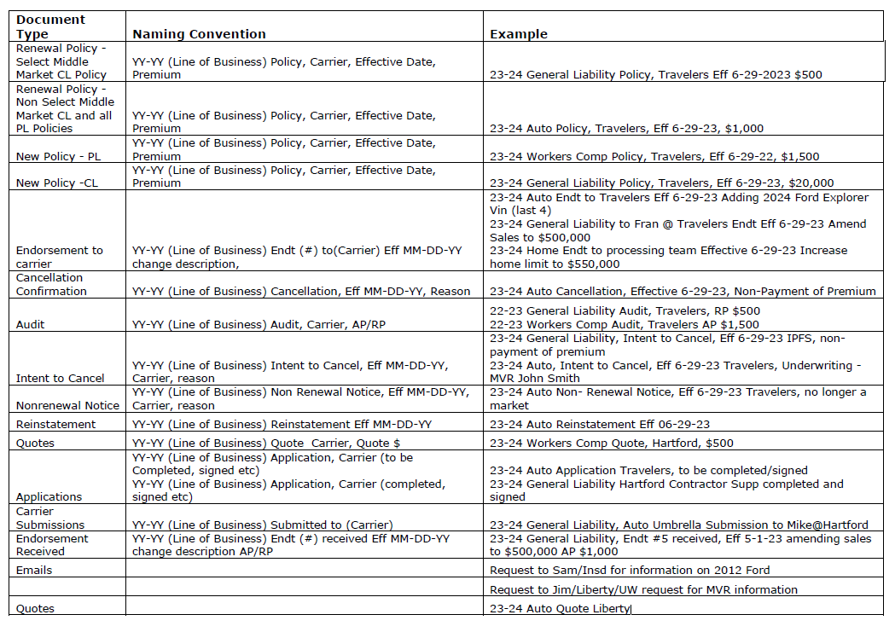

### Add Attachment/Document by Drag and Drop into Epic

|  |
| --- |
| **Drag & Drop from Outlook, network folder, desktop, etc.**   * **Attach to**:   + Final policy documents (Such as new policy, renewal policy, endorsement, dec pages, etc.) should be attached **separately from email** and attached to the corresponding **POLICY**   + Emails or other “busy work” documents should be attached to the corresponding **ACTIVITY** * **Mark as an Important Policy Document**   + Attaching a document to a POLICY will automatically check the box   + Use this feature to quickly find important documents such as policy dec pages, audits, endorsements, or other important documents.   Select the appropriate access level for security  Select the appropriate folder, and subfolder, if applicable.  Check the Client Accessible box to make an attachment available in the client portal (CSR24)  Remove description and update using Platform Naming Convention  ***NOTE: You can also use the Access button to filter attachments, Example: Highlight policy, Access/Attachments, and you will see only the attachments associated with the policy.***   * NOTE: The “Delete original after attaching” box is not available in Browser   **Add Attachment**   * Click the ADD Button (+)   + Select **Existing File** (from outside of Epic (i.e., local or network drive)   + Select **Document** to access the Form Letter library   + Select **eForm** to add a form filler ACORD form from the eForms library |

**Add Attachments and Documents using Attach to Epic Plug–In**

|  |  |
| --- | --- |
| **Attaching New Email Using Attach to Epic Plug-In**   1. Click **NEW Email** Button in Outlook 2. Checkbox **Attach to Epic** Box 3. Add Client Email Address in the To Field, Type Title in Subject Line and Type out body of email. When finished with email and all relevant documents are attached, click **SEND**. 4. Attach To tab will open in Browser 5. Click Magnifying Glass to the right of the Code Field to Locate Client. Click 6. **Finish** Once Account is found. 7. Under Attach To – Identify and select the appropriate dropdown (Policy or Activity) for where the Email and/or documents should be attached to. 8. Once all required fields are completed, Click **Finish** and email will be routed into Applied.   **Attaching Existing Email Using Attach to Epic Plug-In**   1. Highlight or right click existing email in Outlook and select Attach to Epic 2. Attach to Tab will open in Browser 3. Click Magnifying Glass to the right of the Code Field to Locate Client. Click **Finish** Once Account is found. 4. Uncheck Box the **“Delete original after attaching”** box   ***NOTE: If this box does not get un-checked, your email will be deleted from outlook.***     1. Under Attach To – Identify and select the appropriate dropdown (Policy or Activity) for where the Email and/or documents should be attached to. 2. Once all required fields are completed, Click **Finish** and email will be routed into Applied. |  |

### Attachment Access Levels

|  |  |  |  |  |  |  |  |  |  |  |  |  |
| --- | --- | --- | --- | --- | --- | --- | --- | --- | --- | --- | --- | --- |
| Access levels allow restriction of access to attachments by granting security rights to certain groups.  The default Access Level = Public   |  |  | | --- | --- | | **Access Level** | **Description** | | 1 | HIPAA | | 2 | Accounting | | 3 | Management | | 4 | Client Financials | | 5 | HR Consulting | |

### Attachment Actions

|  |  |
| --- | --- |
| Click **ACTIONS** | * **Convert to PDF** – *Converts any document to PDF format in two clicks; can also combine multiple documents into one PDF document* * **Distribute Attachments** – *Uses Distribution Manager to email documents to client contacts* * **Edit Attachment Detail** – *Edit description, association, access levels, and folder* * **Move Attachment** – *Move attachment to another account, folder, etc.* * Policy Checking (Do Not Use) * **Reactivate Attachment** – *Used to remove an attachment from the Inactive area* * **Send via CSIO eDelivery –** NOT APPLICABLE * **Send to eSignature** – *Launches DocuSign* * **Send Via Email** – *Emails attachment through Outlook* |

***PLEASE FOLLOW THE ATTACHMENT NAMING CONVENTION PROTOCOL*** ***JOB AID******.***

### Finding and viewing attachments/documents

|  |
| --- |
| * **Important Policy Documents:** In the attachments list view, click the link “Show Only Important Policy Documents” to view all documents you have marked as “Important”   To revert to all documents, click “Show All Documents.” The link does the filtering for you.     * **Filters: Choose** a filter: Ex. Attached within last 18 months. To see all attachments: Ex. Attached Date within range 1/1/1900 through Open   You can also filter by multiple Types of Business and save the filter default |

### Folders and Folder View

|  |  |
| --- | --- |
| |  | | --- | | Please refer to the Platform Folder Structure Job Aid located on the NJ Platform SharePoint |  * Use folders to organize your client’s documents (Optional) * Folder structure is pre-determined by Acrisure * To see documents in folders, click Attachments view and select Folder View from the drop-down list * Select the folder (i.e., Correspondence, Invoices, Policies, etc.) * In the left panel you can click the expander to see sub folders |

### Form Letter Templates

|  |
| --- |
| To select a form letter:   1. Click the Attachments area in the Client account 2. Click the ADD button (+) 3. Select Document – click Continue      1. Select a Template Folder 2. Select the form letter from the dropdown list      1. Under the Contact tab, check the recipient of the letter 2. Click the Policy/Claim tab and select a policy or claim to reference in the letter      1. Click **Continue** 2. Change attachment description if needed 3. Click **FINISH** 4. Epic data will merge with Microsoft Word and letter will open 5. Update letter as needed. When finished, click the X at the top right to close the Word document 6. Click YES to save document as an attachment 7. The Attachment will be saved in WORD format; however, if you are sending the letter via email or to eSignature, be sure to Convert to PDF first, as follows:    1. Right Click on the WORD attachment    2. Select “Convert to PDF”    3. Click FINISH 8. From the attachments area, find the PDF version of the form letter, right click and either “Send to eSignature” for DocuSign, or “Send Via Email” to send from Outlook. 9. If “Send Via Email” an attachment screen will pop up. You can change the description for the email attachment if needed. |

### Access Filter

|  |
| --- |
| The Access button allows you to filter items for a specific policy, activity, transaction, within the **Client’s Account**  **Example:**   1. From the policy screen, select a **policy** 2. Click the **Access** button 3. Select an option:    * **Activities** = displays all the activities associated with the selected policy    * **Attachments** = displays all the attachments associated with the selected policy    * **Claims** = displays all the claims associated with the selected policy    * **Opportunities** = displays all the sales opportunities associated with the selected policy    * **Services** = displays all the services associated with the selected policy    * **Proofs** = displays all the Proofs associated with the selected policy    * **Transactions** = displays all the transactions associated with the selected policy    * **Auditing** = displays all the documents a client has access to via the CSR24 Portal    * **Notifications** = displays notifications related to the selected policy |

## Policy Basics

### Policy Sources – REQUIRED FIELD

|  |  |
| --- | --- |
| 0. Cross Sell-Platform | **Account Source is a Required Field.**  **Be sure to select the appropriate one for tracking and reporting purposes.**  If you do not know the policy source, select “**Update Needed**” so it can be updated when known. |
| 1. AM/AE Solicited |
| 1. Producer Solicited |
| 2. Referral - Acrisure Cyber Services |
| 2. Referral - Acrisure Title Partner |
| 2. Referral - Association |
| 2. Referral - Broker - Acrisure |
| 2. Referral - Broker - Non-Acrisure |
| 2. Referral - Client |
| 2. Referral - Employee |
| 2. Referral - Financial Partner/WM |
| 2. Referral - Franchisor |
| 2. Referral - GA |
| 2. Referral - Other |
| 2. Referral – Payroll Firm |
| 2. Referral - TPA |
| 3. Marketing - Acrisure.com |
| 3. Marketing - Other |
| 3. Marketing - Telemarketing |
| 4. Other/Unknown |
| 5. Win Back |
| 6. Call In/Walk In |
| Z. AMS Conversion - Unknown |
| Z. Epic Import |
| Z. Update Needed |

### Policy Type Codes

|  |
| --- |
| To reference a full list of P&C Policy types available in Epic, refer to the [Epic Policy Codes](https://acrisure.sharepoint.com/:x:/r/sites/AcriWorld/Shared%20Documents/Enterprise_Solutions_Center/Platforms/New_Jersey/Epic,%20CSR24%20%26%20Indio%20Resources/Epic%20-%20P%26C/Job%20Aids,%20Quick%20Reference%20Guides%20%26%20Cheat%20Sheets/Guide%20-%20Epic%20Policy%20Types,%20v2.26.25.xlsx?d=w736f05f7cd314996aaa4764dd4667965&csf=1&web=1&e=koQkGd) guide available on the [New Jersey SharePoint](https://acrisure.sharepoint.com/sites/AcriWorld/Shared%20Documents/Forms/AllItems.aspx?FolderCTID=0x01200008AF4B3768355743A4CA96C4C3214460&OR=Teams%2DHL&CT=1692990588617&clickparams=eyJBcHBOYW1lIjoiVGVhbXMtRGVza3RvcCIsIkFwcFZlcnNpb24iOiIyNy8yMzA3MDMwNzM0NiIsIkhhc0ZlZGVyYXRlZFVzZXIiOmZhbHNlfQ%3D%3D&id=%2Fsites%2FAcriWorld%2FShared%20Documents%2FAcrisure%20brand%2FNew%5FBrand%5FCenter%2FPlatforms%2FNew%5FJersey%2FEpic%20Resources&viewid=f6de5ddd%2Dd0d1%2D4fcf%2Daf55%2D3160191957d5) Page |

### Policy Statuses

|  |  |  |
| --- | --- | --- |
| **CODE** | **DESCRIPTION** | **WHEN USED** |
| **NEW** | New | New policy |
| **NBR** | New - BOR | New policy acquired via BOR |
| **CNW** | Cancelled (New) | Cancelled policy when original policy status was NEW |
| **CRN** | Cancelled (Renewal) | Cancelled policy when original policy status was REN |
| **CRW** | Cancelled – Rewritten (Flat or Mid-Term Rewrite) | Cancelled from original carrier and rewritten with another carrier |
| **X-N** | Not-Renewed (New) | Policy went to term but did not renew – original status = NEW  **(Carrier Non-Renews or client does not renew)** |
| **X-R** | Not-Renewed (Renewal) | Policy went to term but did not renew – original status = REN  **(Carrier Non-Renews or client does not renew)** |
| **XNW** | Shared New | Shared New |
| **XRW** | Shared Renewal | Shared Renewal |
| **REN** | Renewal | Renewed policy with same carrier |
| **REW** | Renewal – Rewrite (First Renewal w/ New Carrier) | Policy rewritten with another carrier on renewal |
| **ZER** | Created In Error | Use when deprecating policy for conversion cleanup, etc. |
| **ZIN** | Info Only | Use for Info Only policies which are not active with any carrier |

### Select the Correct Issuing Company (ICO)

|  |
| --- |
| **When setting up a policy, it is critical that the correct writing/issuing company be selected. This selection will pre-fill the correct Billing Company (PPE (Premium Payable Entity)).** |

### Select the Correct Broker Payable Contract

|  |
| --- |
| * **If the PPE is a Broker,** change the Premium Payable CA to BR and select the Broker from the dropdown list * Select the correct Payable Contract by clicking the dropdown arrow * **This step is critical to align accurate Accounting functions** |

### Change Policy Dates

|  |
| --- |
| 1. Select Policy 2. **ACTIONS** > Change Effective/Expiration Dates 3. Enter new dates (Note: Service Summary Row Dates may need to be updated as well)      1. Activity **CEED** - Change to Closed if no follow-up needed |

### Copy Policy

|  |
| --- |
| Use this workflow when you need to copy an entire policy to the same account or to another account.   1. Highlight the policy you wish to copy 2. Click **ACTIONS > Copy Policy** 3. Choose To Another Account or To Current Account 4. Enter Lookup Code of the Other Account (if copying to another account) 5. Fill in structure and policy detail 6. Click Detail 7. Policy has now been copied. Enter additional details as needed. |

### ACORD Application Prefills

|  |
| --- |
| Prefilled ACORD applications will be configured by your platform system administration for your convenience   * Use prefills to enter common information or agency standard limits/coverages * The prefill can then be added when the policy is created by clicking the dropdown list and selecting the prefill.      * Prefills can also be added while in the application (navigation panel is open to the policy form), then clicking Actions / Select Prefill. Service Summary Stage must be In Process. |

### Print Application

|  |
| --- |
| 1. With the policy selected, click **ACTIONS** **> Review Application** 2. Click the **Distribution** Tab    1. Select Print as the distribution method    2. Click the Download & Print button      * 1. Download will appear at the bottom left     And is added to your Downloads Folder so you can print it locally or print from the PDF file    ***Do not use the PRINT button – this function downloads and prints a watermarked “House Copy”*** |

### Service Summary Row and Stages

|  |
| --- |
| Service Summary Rows are very important in Epic as these represent the chronological order of services provided to a policy. Each service/action taken to a policy will be reflected in the service summary row in order of most recent, usually. When viewing a policy in Epic it will usually default to the most recent service summary row, but it important to be aware of what service summary row you are viewing.  From the policy view screen in a client account, highlight the policy and make note of the SSR. Each SSR represents the policy details at that point in the policy term. For the example below: SSR#2 will display the policy details for the endorsement effective on the date noted on the SSR. SSR line #1 will not reflect the added vehicle, since the first SSR is the new/renew details at the effective date.    NOTE: when viewing a multi-line package, highlight one of the lines under the policy header to view the Service Summary Row. In the screen shot below, the CPK1 is selected but there are not any SSR’s displayed.    Single click on a line of business and the Service Summary Rows will be displayed, see below    Having multiple service summary rows to view allows us to be able to see the policy details at any given date during the term. To compare the changes made between one service summary row and another, from the tool bar, go to **ON Demand>Service Summary Comparison**  The list below explains what the different stages represent. The stages reflect the actions taken in EPIC and are not always reflective of the status chosen in the policy details. It is always important to make sure that the status of the policy is representative of the current stage of the policy details.   * **In Process** – Policy details are not complete, and the application is open for edits * **Submitted** – it has been sent to the carrier for action and the application or endorsement is now locked down * **Issued** - policy or endorsement has been issued by the carrier or confirmation of coverage received from carrier * **Not Issued** – Use only if policy or endorsement has not been issued by the carrier and it was previously in submitted stage * **Cancelled** – Cancellation has been confirmed by the carrier   **Migrated** – one time use for conversion and simulates the stage of submitted |

### Multi-Year Policies

|  |
| --- |
| * The way multi-year policies are set up in Epic is dependent on when premium is billed/collected. * If premium is collected at policy inception for the entire policy term add the policy with an expiration date showing the true end of the policy term.   *Example: Jane Smith has a three-year Liability policy. The carrier is collecting the full premium at the policy inception. You are billing the client for the full three-year premium.* *Policy would be entered with an effective/expiration date of January 1, 2020, to January 1, 2023.*   * If premium is collected EACH YEAR on a multi-year policy, add the policy with a one year effective/expiration date. At the end of the first year, renew the policy and bill the second-year premium. You would continue to renew the policy until the end of the policy term.   *Example: Michael Jones has a three-year Liability policy. The carrier is collecting a third of the premium for the first year, a third of the premium for the second year, and a third of the premium for the third year. The policy would be entered into Epic as an annual term (i.e., January 1, 2020, to January 1, 2021). At the end of the first year, the policy would be RENEWED, and* *the second third of the premium would be billed.* *Policy would need to be renewed each year for three consecutive years.* |

### Continuous Policies (policies that do not expire)

|  |
| --- |
| * **Personal & Commercial Policies**:   + If an Agency Bill or Direct Bill policy and expiration date is known, enter as reflected on policy or binding documents.   + If a true continuous policy (i.e., E&O, Tail Coverage, etc.) where expiration date is not known and policy changes are not expected, enter the expiration date as 9999.   + If policy changes are expected, enter policy as an annual term and renew from year to year until coverage ends. * **Individual Life & Health & Employee Benefits Policies:**   + If expiration date is known, enter as reflected on policy or binding documents/service contract.   + If expiration date is not known, enter expiration date with a 9999 year. * **Client Contracts/Fee Policy Types:**   + If a service contract/fee policy type and expiration date is known, enter expiration date as reflected on service contract.   + If a service contract/fee policy type and expiration date is not known, enter expiration date as a one-year term and renew annually until the contract is cancelled.   + This process would be continued until the carrier is no longer collecting annual premiums or is cancelled. |

## New Jersey Platform Epic Structure

|  |  |  |
| --- | --- | --- |
| **AGENCIES** | | |
| 1NJ | Acrisure NJ Partners Insurance Services, LLC | |
| BGR | Acrisure NJ Partners Risk Management Solutions, LLC | |
| MAC | Acrisure, LLC dba MacLean Insurance Agency | |
| RPI | Acrisure, LLC dba Robert P. Petri and Daughter Insurance Agency | |
| **BRANCHES** | | |
| 1NJ | Acrisure NJ Partners Insurance Services, LLC | |
| BRM | Balken Risk Management | |
| BEC | Beckerman & Company | |
| BGR | BRM Claims Administrators | |
| BEV | Bob Evans Agency | |
| CWD | Coastwide Insurance Associates | |
| CNS | Cornerstone Insurance Group | |
| DNJ | Doyle Alliance Group | |
| GDB | George Dawli Book of Business | |
| HOB | Henry O Baker Insurance Group | |
| HRP | Hughes Recreational Products | |
| IDA | Independent Distributor Alliance | |
| IMA | IMAC Insurance Agency | |
| LES | Leading Edge Safety and Health | |
| NAI | NAIMC | |
| PEA | Public Entity Advocates | |
| POL | Polaris Galaxy Group | |
| RIG | Reliance Insurance Group | |
| SAN | Sanford Insurance Group | |
| SFG | Scirocco Financial Group | |
| MAC | MacLean Insurance Agency | |
| RPI | Robert Petri & Daughter | |
| SUB | Suburban General Insurance Agency | |
| **DEPARTMENTS** | | |
| ARR | Risk Resources | Fee based services for High Net Worth (risk management, loss control, etc.)  See Service Contracts |
| OTH | Non-Insurance Products | Acrisure Title referrals |
| PEL | Personal Lines - Large | $1000+ Account Revenue |
| PEM | Personal Lines - Middle | $250-$1000 Account Revenue |
| PES | Personal Lines - Small | <$250 Account Revenue |
| **PROFIT CENTERS** | | |
| COR | CORE | Core Business – Use when no other profit center applies |
| EEA | PL Employee Account | Use for Employees who have their personal insurance business with Acrisure (account will be locked down) |
| HNW | PL High Net Worth | Smaller accounts with high-valued property ($2M+) |
| MAF | PL Mass Affluent | Well-rounded accounts with high-valued property ($2M), domestic workers, etc. |
| PLB | Personal - Brokered | Formerly CCW-Coastal Program |
| ASC | Acrisure Service Center |  |

## Best Practice Guide for Addresses & Contacts

***Contact information is an important part of the Client Account record. Please follow these guidelines to keep the data clean.***

### Client Addresses

|  |
| --- |
| * **First Address Line**: Enter Street address only – No Names, DBA’s, or PO Boxes * DO NOT add P.O. Box instead, add as another contact with L-Mailing as the description   A screenshot of contact information  Description automatically generated   * + It is okay to include Suite Number, Apartment Number, and Floor Number with the street address.   **A screen shot of a computer  Description automatically generatedA screen shot of a computer  Description automatically generatedDO NOT INCLUDE DBA NAME, C/O OR NAME OF INSURED CONTACT IN THE FIRST LINE OF THE ADDRESS FIELD.**   * **Be sure to enter City, State & Zip Code** * **Address validation tools** are used in Epic Browser and AcriVision mapping and will create errors if the street address is not shown on the first line. * **Add a Contact and Address Description:**   + Contact – Named Insured   + Address – Primary Physical Address * **Additional Mailing or Billing addresses** can be set up as Contacts – do not forget to add address and Contact descriptions such as DBA, L-Billing, or Post office Box. |

### Add Individual Client Contact

|  |
| --- |
| 1. From the client’s account, click **Contacts** in the left panel 2. Click the ADD button      1. Select the **Individual** radio button 2. Enter First Name, Last Name 3. Category: Indicate whether contact only, policy only, or both contact & policy 4. Description: Select the appropriate description for this contact 5. Enter the address. If the account address is the same as the contact address, check the box for Use Account Address 6. Enter phone number (indicate if mobile) and email address      1. Click DETAIL if you wish to add additional information like date of birth, SSN, personal info, etc.   If not, click FINISH. |

# EPIC WORKFLOWS



## New Business Workflow

**The following lists represent activities that might be part of the New Business process. Individual user results may vary and not all new business processes will require the use of all these system generated and/or manual activities.**

|  |  |  |  |
| --- | --- | --- | --- |
| **SYSTEM GENERATED/ACTION ACTIVITIES** | | | |
| Add Account | | ADD1 | Adding account that is already bound business |
| Add Account | | ADD2 | Adding account that is a prospect and not bound business |
| Add Policy | | APOL | Adding a policy |
| Add Policy | | BORP | Adding a policy brought in by BOR |
| New Personal Quote Started | | NPQS | # New Personal Quote Started (Epic Quotes) |
| New Marketing Submission | | AMMK | # Added master marketing submission for &AcctName& |
| ACTIONS > Send to E-Signature | | ESIG | # Send to eSignature |
| **MANUAL ACTIVITIES** | | | |
| GACR | Acrisure Real Estate Services Referral | | |
| GACS | Acrisure Cyber Services Referral | | |
| GAPT | Appointment with &AcctName& | | |
| GCAL | Call from &AcctName& | | |
| GMKT | Original Marketing File - Used to Track & Collect New Business Underwriting Information | | |
| PBND | Bind Request to Carrier - PL | | |
| PNCO | New PL Client Onboarding | | |
| PPCK | PL - Policy Checking | | |
| QNEW | Quote - New Business | | |

### Add New Account

|  |
| --- |
| 1. Receive request from client for quoting 2. Add Prospect in Epic, including Client name(s), addresses, phone numbers, email addresses, and contacts living in the household. 3. Add notes to the **ADD2** (adding a prospect) or **ADD1** (if already bound business) activity, who, what, why, etc. - then close the activity successful 4. If new business is being taken over via BOR follow the Add Policy Workflow and choose the **BORP** activity code |

### Add Prospect or Insured

|  |
| --- |
| 1. Click **LOCATE** 2. Click the **Add** button (+) 3. **Add Account**    1. Individual or Business = Individual    2. Type of Business = Personal      1. **Account Information**    1. **Client Type** – Prospect or Insured    2. **Account Source** Required Field – Select Appropriate from the dropdown list    3. **Structure** – Select Agency & Branch from dropdown list      1. **Contact Information**    1. **Primary Contact and Additional Contact (if applicable) when entered will generate the account name.**    2. **Address** – enter valid address (will be verified and auto filled when selected)    3. Popup will alert you, if possible, address duplicates are found 2. **Phone and Email**    1. Enter Type (i.e., Mobile, Residence, etc.)    2. Enter Number (must include all 10 digits)    3. Permission – select from dropdown    4. **SMS** = check to enable this number for SMS Text Messaging    5. Click Yes to enable conversational SMS for this number      * 1. Click **+Phone** to add additional phone numbers   2. enter Email and Contact Preferences (if known, at this time)      1. **Agency Information**    1. **Agency Defined Categories** – predetermined by the agency; used to tag an account for a specific reporting purpose (i.e., to mark as a VIP account)    2. **Relationships** – add related accounts (i.e., owned businesses or family members not in the same household, etc.)      1. Click **Save Account**      1. **Activity**: **ADD2** (Prospect) or **ADD1** (Insured)    1. Defaults closed    2. Add **Notes** (how account was acquired, what has been done for this account thus far, etc.)    3. Click **FINISH** 2. **Account Details**    1. Click the **Servicing Tab** and enter staff names in Servicing Role(s), as applicable |

### Quoting/Marketing/Binding

|  |
| --- |
| 1. Send New Business Questionnaire through Indio or via email. 2. When Questionnaire is returned, attach to client account 3. Proceed with the following processes based on which marketing method is being used.   **Quoting through Epic Quotes:**   1. Use EpicQuotes for rating – See Epic Quotes Job Aid for New Business Quoting 2. Activity = **NPQS** to document file and save attachments    1. Close activity “successful” when bound    2. Close activity “unsuccessful” if quote not taken – list reason and add notes 3. When bound on carrier website, mark as **Sold in Epic Quotes** area and follow steps listed in Epic Quotes Job Aid to **generate policy shell from Epic Quotes area**.   **Do not** **add policy shell in Epic if using Epic Quotes**  **Quoting manually on Carrier or Broker Website:**   1. Use Marketing Lite to manage submissions – See Marketing Lite Job Aid for details. 2. Add one **QNEW** activity for all quoting.    1. Create notes and save attachments to the **QNEW** activity 3. Present quotes to client 4. When carrier selected, send Bind Request to carrier via email; save sent email to **QNEW** activity. 5. When policy is bound, **add policy shell in Epic**. If policy will download, you do not need to complete all policy details. Policies that will not download will need to have all the coverage tabs competed with policy details. 6. From policy:  **ACTIONS > Update Stage to Submitted** 7. **Change Client Type Prospect to Insured**:    * 1. From the Account Detail Screen, click **ACTIONS>Change Client Type**      2. Change Client Type from Prospect to Insured. Click **YES**      3. **from** Activity **CCTI** (closed); click Finish. |

#### Add Policy Shell

|  |  |  |  |  |  |  |  |  |  |  |
| --- | --- | --- | --- | --- | --- | --- | --- | --- | --- | --- |
| 1. Click **Policies** from the Navigation Panel (left) 2. Click the **ADD** button - select **Contracted** policy 3. Enter Policy Details:    1. **Select Policy Type** from dropdown list (click the Description header to sort by description)    2. **Policy Line** – description will default    3. **Policy number** – enter Policy Number or TBD if unknown    4. **Effective/Expiration date**: update as needed    5. **Source** – Choose from the drop down **(Required Field)**    6. **Agency = 1NJ**    7. **Branch = 1NJ** **unless** the entity you work for is in earnout then use the entities legal business name    8. **Department:** Select the department based on the **account** **revenue** size  |  |  |  | | --- | --- | --- | | PEL | Personal Lines - Large | $10k Rev + | | PEM | Personal Lines - Middle | $2500-$10k Rev | | PES | Personal Lines - Small | <$2500k Rev |  * 1. **Status** = Select **NEW**   2. **Issuing Location** – verify   3. **Bill type**: Select Agency or Direct Bill   4. Select **Profit Center** = Select CORE **unless** the policy fits into a specific **practice group**  (Note: Options shown in the dropdown are based on Department selected)   5. **Issuing Company** – Select from dropdown list (Click description header to sort by Name)   6. **Premium Payable Entity** - Select from dropdown list (Click description header to sort by Name)      * 1. If PPE is a Broker, change **CA** to **BR** and enter broker name from dropdown list     **NOTE: Be sure to select the appropriate PPE Contract if BR is selected**     1. **Line Commission**: Enter carrier policy commission percentage. This can be found on the quote or carrier/broker invoice. **(If unknown enter 1%)** 2. **Line estimated premium:** Estimate Annual Premium only (no taxes or fees). Enter premium quoted.      1. Click **Detail** 2. **ACTIVITY:** Select **APOL**    1. Verify Who/Owner    2. Follow-up/Start Date    3. Add Notes    4. Click **Finish** 3. From the Navigation Panel, click **Servicing/Billing > Line**    1. **Pr/Br Tab (Required)**: Each policy requires at least one PPAY (NOTE: PPAYs are Employees; BPAYs are outside brokers)       1. If a Producer is getting paid commission on a policy, enter his/her name from the dropdown list.       2. When selected, their producer commission agreement will default          1. Be sure to enter 100% Production Credit (this is not commission related but gives the producer credit for booking the business written). **NOTE:** BPAYs never receive Production Credit          2. If adding a Broker Receivable, you must add a PPAY of House 1NJ at 100% Production credit    2. **Servicing Tab**: Verify Servicing Roles 4. **Non-Downloaded Policies** - Make sure to update Policy Detail in the left Navigation panel 5. Click the X on the left panel  Click – Yes Perform Action > Update Stage to Submitted; click Finish. |  |

### Policy Received from Carrier

|  |
| --- |
| **DOWNLOAD:**   1. Downloaded policies will automatically update policy stage to Issued with the **policy status to NEW.** 2. **ZNEW** activity will generate and is set to close automatically 3. Review **Daily Download Report** to review downloads received that day, and the **Download Audit Report** to update policy/client record with missing information. 4. Policy Check for accuracy: Manually create an **PPCK** Activity; assign to 3rd Party Vendor or Account Manager    1. If the Policy is NOT accurate, leave **PPCK** open for follow up; send to carrier for correction. 5. **Attach** policy dec to **Policy** in client's account. 6. Close the open **APOL** (from the Home Base) as successful 7. Delivery policy to client if not sent directly by the carrier. Note the APOL activity with delivery details and email.   **NON-DOWNLOAD:**   1. Policy Check for accuracy: Manually Create open **PPCK** Activity; assign to 3rd Party Vendor or Account Manager 2. If Policy NOT accurate, leave **PPCK** open for follow up; send to carrier for correction. 3. **Attach** policy dec to **Policy** in client's account. 4. From policy: **ACTIONS > Issue/Not Issue Policy** 5. Issue; enter/verify policy number; verify effective/expiration dates; verify estimated Premium. 6. Click **Close Activity tab.** 7. Delivery policy to client if not sent directly by the carrier. Note the APOL activity with delivery details and email.   ***Manual Policy Check Activity PPCK – Create Manual Activity to Check for Accuracy – reassign Who/Owner to 3rd Party Vendor Workgroup or Account Manager.***  **\*Send Welcome Letter to Client**  Add Client to CSR24 Client Portal  Issue Proofs – ID Cards, Evidence  [Agency Billing/Account Activities](https://acrisure.sharepoint.com/:w:/r/sites/AcriWorld/Shared%20Documents/Enterprise_Solutions_Center/Platforms/New_Jersey/Epic,%20CSR24%20%26%20Indio%20Resources/Epic%20-%20Accounting%20Training,%20Workflows%20%26%20Guides/Platform%20Accounting%20Activities%20Guide.docx?d=w1244256f5a664989bdc373dd69614de6&csf=1&web=1&e=a0PpbA) workflows are located on the NJ SharePoint |

### Add Policy Workflow for BOR and Non-Download

|  |  |
| --- | --- |
| Follow Add Account Workflow for new clients or if existing client locate Client Account.  1. Click Policies from the Navigation Panel 2. Click the **ADD** button - Select whether the policy is Prospective or Contracted 3. Enter Policy Type from dropdown list 4. Change Policy Description as needed 5. Enter policy number if known or TBD 6. Verify the following:    1. **Effective and expiration dates** (defaults to system date and one year term)    2. **Source:** choose from the dropdown **(required field)**    3. **Structure**: Verify Agency, Branch, Department    4. **Lines of Business**:    5. Policy Line    6. Status = “**BOR” for BOR or “New” for marketed**    7. Select Profit Center    8. Issuing Company    9. Premium Payable Company. If PPE is a Broker, change **CA** to **BR** and enter broker name from dropdown list    10. Add Carrier Commission percentage **(if unknown add 1%)**    11. Click **Detail**    12. Activity = **BORP for BOR or APOL for marketed lines**    13. Add detailed notes (leave open for follow up on receipt of policy) - click **Finish**. 7. Complete:    1. **PR/BR Tab:** Enter PR/BR name from dropdown list if area is not defaulted.    2. **Servicing Tab:** Enter Policy Producer and Policy Servicer    3. **Billing Tab:** Verify Invoice information and delivery method    4. **Line Tab:** Enter Estimated Premium and Estimated Commission if known 8. Follow Steps for Policy Received from Carrier above. 9. After Policy Checking is Complete, close out **BORP/APOL** activity with detailed notes and attach final documents to the **Policy**. |  |

## Renew Policy Workflow

|  |  |  |
| --- | --- | --- |
| **System Generated / Action Activities** | | |
| Actions > Renew | **RPOL** | # Renewal &PolType& &PolEffDate& |

|  |  |
| --- | --- |
| **Manual Activities** | |
| GAPT | Appointment with &AcctName& |
| GCAL | Call from &AcctName& |
| SARV | Account Review |
| PMVR | PL - MVR Request |
| PPCK | PL - Policy Checking |
| PRSK | Account At Risk |

### Downloaded Renewals

|  |
| --- |
| 1. Downloaded policies will automatically renew new term as **Issued** and update status **to REN.** 2. This generates a **ZREN** activity which is automatically closed 3. Review **Daily Download Report** to review downloads received that day, and the **Download Audit Report** to update policy/client record with missing information. 4. eDoc received from carrier should be associated to the policy line in Epic. If no eDoc received, pull policy dec from the carrier website and attach to policy line. 5. Policy Check for accuracy    1. manually open **PPCK** Activity and assign to 3rd Party Vendor or Account Manager.    2. **If policy is correct,** add notes as applicable and close **PPCK**.    3. **If policy is incorrect,** keep the **PPCK** open and send request back to the carrier for correction. When correction is received, check again 6. Deliver policy to client if not sent directly by the carrier. Note the **PPCK** activity when the process is completed.   Issue Proofs – ID Cards & Evidence of Property |

### Non-Downloaded Renewals

|  |
| --- |
| 1. Review upcoming renewal using Renewal Manager or 30-day renewal report. 2. Receive copy of policy in the agency & review new term policy dec. 3. From policy in Epic, **ACTIONS > Renew**. 4. Activity = **RPOL** Activity – add notes as needed and close successful.    1. Review details (policy number, effective/expiration dates, etc.)    2. **Policy status = REN**    3. Click **Finish**    4. Attach dec pages to the **Policy** line 5. Policy Check from expiring term for accuracy    1. manually open **PPCK** Activity and assign to 3rd Party Vendor or Account Manager.    2. **If policy is correct,** add notes as applicable and close **PPCK**.    3. **If policy is incorrect,** keep the **PPCK** open and send request back to the carrier for correction. When correction is received, check again 6. Deliver Policy to client if not sent directly by the carrier. Note the **RPOL** activity with delivery details.   Issue Proofs – ID Cards & Evidence of Property  [Agency Billing/Account Activities](https://acrisure.sharepoint.com/:w:/r/sites/AcriWorld/Shared%20Documents/Enterprise_Solutions_Center/Platforms/New_Jersey/Epic,%20CSR24%20%26%20Indio%20Resources/Epic%20-%20Accounting%20Training,%20Workflows%20%26%20Guides/Platform%20Accounting%20Activities%20Guide.docx?d=w1244256f5a664989bdc373dd69614de6&csf=1&web=1&e=a0PpbA) found in NJ Platform SharePoint |

## Rewrite Policy Workflow

|  |  |  |
| --- | --- | --- |
| **System Generated / Action Activities** | | |
| Actions > Renew | **RREW** | # Rewrite &PolType& &PolEffDate& |

|  |  |
| --- | --- |
| **Manual Activities** | |
| GAPT | Appointment with &AcctName& |
| GCAL | Call from &AcctName& |
| SARV | Account Review |
| PBIQ | Billing Inquiry |
| PCIQ | Coverage Inquiry |
| PCRF | PL - Refer Claim to Claims Team |
| PEOP | PL - EOP Request |
| PLCR | PL - Loss Control Recommendation |
| PLRR | PL – Renewal Review &PolExpDate& &PolType& |
| PMVR | PL - MVR Request |
| PPCK | PL - Policy Checking |
| PRSK | Account At Risk |

|  |
| --- |
| **Best Practices**   * Review upcoming renewal list 30 days? in advance (or use Renewal Manager) * Remarket to carriers via Epic Quotes or via email * When Rewriting a policy, the ***ACTIONS>Renew*** workflow is **required** to create a policy shell and to ensure the downloaded policy comes through properly. The below steps must be done **within 24 hours** of binding the policy with the carrier. |

### Remarket Downloaded Policies:

|  |
| --- |
| **Policies rewritten from one carrier to a new carrier will use Actions > Copy Policy instead of Actions > Renew and the expiring carrier renewal download will need to be cancelled flat.**  **Copying the policy instead of renewing it will make sure the Rewritten policy is downloaded correctly. Confirming the expiring carrier renewal download is cancelled will remove the policy from Expiration and Potentially Missed Renewal reports.** |
| If Remarketed Policy **Downloads:**   1. Select **EXPIRING** policy term 2. Click **Actions > Copy Policy** 3. **Destination** – To current account 4. Verify **Structure** 5. **Policy Detail** 6. Description 7. Policy Number 8. Effective/Expiration Date 9. **Lines of Business** (if more than one line of business, each line needs to be updated) 10. Verify Line(s) of Business 11. Policy Status **REW – Rewrite** 12. Billing – **Agency** or **Direct** 13. Profit Center – Select from dropdown 14. Issuing Company/Premium Payable 15. **Line Commission –** Enter carrier commission percentage if known  * **If Commission is Unknown –** * Check the box to use commission agreement * Select the policy type with **Acrisure Estimated Rate** in the dropdown      * If commission agreements are **not** in dropdown; enter 1%  1. Click **Detail** 2. Policy Opens - Click **Servicing/Billing > Line** on left Navigation Panel 3. **Servicing** tab – Verify required Servicing Contacts 4. **Pr/Br Commissions** tab – Verify Commission Agreement 5. Click the **X** on the left Navigation Panel to close out of Policy Detail 6. If Policy has been Submitted to the Carrier for binding – Close Policy Detail > **Update Stage to Submitted** 7. Click **Finish** 8. When **Expiring** carrier has downloaded the renewal; proceed with one of the following options:  * Confirm for carrier Cancellation Download and update policy status to **CRW – Cancelled – Rewritten**   Follow the Cancellation Workflow to cancel the downloaded renewal flat. Policy status of **CRW – Cancelled – Rewritten** and utilize the **CREW** activity code if needed. |

### Remarket Non-Downloaded policies:

|  |
| --- |
| 1. Remarket to carriers via carrier website, use Marketing Module Lite 2. Use the manual **QREW** activity to document file and save attachments    1. Use one **QREW** Activity for each carrier quoted 3. Review all carrier quotes; update **QREW** activities **using Amount qualifier (Premium Quoted)** 4. Send proposal to client: **PROP** activity   **When New Carrier is selected:**   1. Send Bind Request to carrier via email; save sent email to **QREW** activity 2. Close **QREW** for binding carrier as successful. Use the open **BND1** activity open for receipt of policy 3. Close **QREW** for all other carriers as unsuccessful, select reason and add notes |

### Policy Received from Carrier

|  |
| --- |
| 1. Policy Check for accuracy. Open **RREW** or **BND1** Activity and reassign to Third-Party Vendor or agency Processor 2. Processor will create a note when policy checking complete and will attachpolicy document to **Policy** in client's account (if not received via eDocs)   **If policy NOT downloaded:**   * 1. Highlight policy, click **ACTIONS > Issue/Not Issue Policy**   2. **Issue**; enter/verify policy number; verify effective/expiration dates   3. Click **Close Activity tab**:  close **RREW/BND1** successful   **If policy is downloaded:**   1. The download will issue the policy and update detail 2. The open **RREW/BND1** Activity will need to be closed manually   Deliver policy to client is not done directly by the carrier and note **RREW/BND1** with delivery details  Add Client to CSR24 Client Portal (if applicable)  Issue Proofs: EPIC Auto ID Cards and Evidence of Property  [Agency Billing/Accounting Activities](https://acrisure.sharepoint.com/:w:/r/sites/AcriWorld/Shared%20Documents/Enterprise_Solutions_Center/Platforms/New_Jersey/Epic,%20CSR24%20%26%20Indio%20Resources/Epic%20-%20Accounting%20Training,%20Workflows%20%26%20Guides/Platform%20Accounting%20Activities%20Guide.docx?d=w1244256f5a664989bdc373dd69614de6&csf=1&web=1&e=a0PpbA) found on NJ Platform SharePoint |

## Policy Change Workflow

|  |  |  |
| --- | --- | --- |
| **SYSTEM GENERATED / ACTION ACTIVITIES** | | |
| ACTIONS > Endorse/Revise Existing Line | CHGE | # Change &ServSumEffDate& &ServSumDesc& |
| ACTIONS > Endorse/Revise Existing Line | CHGA | # Audit &ServSumEffDate& &ServSumDesc& |
| ACTIONS > Endorse/Revise Existing Line | CHGI | # Internal Correction &ServSumEffDate& &ServSumDesc& |
| ACTIONS > Endorse/Revise - Add Line Mid-Term | CHGL | # &ServSumEffDate& &ServSumDesc& |

|  |  |
| --- | --- |
| **MANUAL ACTIVITIES** | |
| GAPT | Appointment with &AcctName& |
| SARV | Account Review |
| PBIQ | Billing Inquiry |
| PCIQ | Coverage Inquiry |
| PEOP | PL - EOP Request |
| PLCR | PL - Loss Control Recommendation |
| PMVR | PL - MVR Request |
| PPCK | PL - Policy Checking |

|  |
| --- |
| **Best Practices**   * When Endorsing a policy, the ***ACTIONS>Endorse/Revise Existing Line*** workflow is **required** to create a detailed service summary row and to ensure the endorsement download comes through properly. The below steps must be done **within 24 hours** of binding the endorsement with the carrier. |

### Process Change Request (Existing Line)

|  |
| --- |
| 1. Receive policy change request from client 2. In Epic – **ACTIONS > Endorse/Revise Existing Line;** enter:    1. Effective date of change    2. Description of change    3. Details    4. **Activity = CHGE**    5. Add detailed notes:  who called, what did they ask for, your responses or direction, etc.    6. click Finish   **Downloaded policies**:   1. Click the X in the left panel 2. Yes, perform action: **Update Stage to Submitted** 3. Process changes on carrier website 4. Attach bind confirmation, emails with client/carrier, etc. to the **CHGE** activity   **Non-Downloaded Policies:**   1. Update ACORD detail in Epic to include the change requested 2. Prepare ACORD Change Request Form (if applicable) and/or email change to carrier    1. Attach email/change request to the **CHGE** activity    2. Leave Activity Open for follow up 3. Click the X on the left panel – **Update Stage to Submitted**   **When endorsement is received in the agency, either via eDoc or email or USPS, proceed to the** **Endorsement Received Workflow****.**  Issue Proofs: EPIC Auto ID Cards and Evidence of Property  [Agency Billing/Accounting Activities](https://acrisure.sharepoint.com/:w:/r/sites/AcriWorld/Shared%20Documents/Enterprise_Solutions_Center/Platforms/New_Jersey/Epic,%20CSR24%20%26%20Indio%20Resources/Epic%20-%20Accounting%20Training,%20Workflows%20%26%20Guides/Platform%20Accounting%20Activities%20Guide.docx?d=w1244256f5a664989bdc373dd69614de6&csf=1&web=1&e=a0PpbA) found on NJ Platform SharePoint |

### Process Change Request (Add Line Mid-Term)

|  |
| --- |
| **Best Practices**   * This process should only be followed if we are adding an additional Line of Business to a Package policy Mid-Term and the **policy number is the same.** |
| 1. Receive policy change request from client 2. In Epic – **ACTIONS > Endorse/Revise Add Line Mid-Term;** enter:    1. Effective date of change    2. Description of change    3. Click the **ADD** (+) button within the Line of Business section    4. Add Line Code, Status, and Issuing Location    5. Verify Profit Center, ICO/PPE    6. Add Carrier Commission percentage if known **(if unknown add 1%)**    7. Click **Detail**    8. **Activity = CHGL**    9. Add detailed notes:  who called, what did they ask for, your responses or direction, etc.; click **Finish**   **Downloaded Policies:**   1. Process change on carrier website 2. Attach bind confirmation, emails with client/carrier, etc. to the **CHGL** activity 3. Click the X on the left panel to close out of the policy detail 4. Click Yes Perform Action > **Update Stage to Submitted**   **Non-Downloaded Policies:**   1. Update ACORD detail in Epic to include the change requested 2. Prepare ACORD Change Request Form (if applicable) and/or email change to carrier    1. Attach email/change request to the **CHGL** activity    2. Leave Activity Open for follow up 3. Click the X on the left panel – **Update Stage to Submitted**   **When endorsement is received in the agency, either via eDoc, email or USPS, proceed to the** **Endorsement Received Workflow****.**  Issue Proofs: EPIC Auto ID Cards and Evidence of Property  [Agency Billing/Accounting](https://acrisure.sharepoint.com/:w:/r/sites/AcriWorld/Shared%20Documents/Enterprise_Solutions_Center/Platforms/New_Jersey/Epic,%20CSR24%20%26%20Indio%20Resources/Epic%20-%20Accounting%20Training,%20Workflows%20%26%20Guides/Platform%20Accounting%20Activities%20Guide.docx?d=w1244256f5a664989bdc373dd69614de6&csf=1&web=1&e=a0PpbA) Activities found on NJ Platform SharePoint |

### Endorsement Received from Carrier

|  |
| --- |
| **Downloaded Policies:**   1. Review daily download list – review download audit report and update missing information 2. Policy check **(PPCK*)** to verify what was requested is correct in the endorsement. 3. Close the **CHGE** activity. 4. Download will update the service summary row and **Issue** the endorsement 5. Attach actual policy endorsement to the **Policy** in Epic (if not already attached as eDoc download)   ***If Endorsement is incorrect, keep the PPCK open then send request back to the carrier or to servicer for correction. When received, check again, then close the PPCK activity.***  **Non-Downloaded Policies:**   1. Policy check **(PPCK*)** to verify what was requested is correct in the endorsement.    1. **If Endorsement is correct,** add notes as applicable and move to step 3.    2. **If Endorsement is incorrect,** keep the **CHGE** open and send request back to the carrier for correction. When update is received, check again, then follow steps 3-4. 2. Attach policy endorsement to the **Policy** in Epic 3. From policy, **ACTIONS > Issue/Not Issue Endorsement** 4. Verify effective date of change and other details 5. Select: Issue 6. Click **Open Activity** tab: Enter note if needed; Close the **CHGE** activity as successful; click Finish   Issue Proofs: EPIC Auto ID Cards and Evidence of Property  [Agency Billing/Accounting Activities](https://acrisure.sharepoint.com/:w:/r/sites/AcriWorld/Shared%20Documents/Enterprise_Solutions_Center/Platforms/New_Jersey/Epic,%20CSR24%20%26%20Indio%20Resources/Epic%20-%20Accounting%20Training,%20Workflows%20%26%20Guides/Platform%20Accounting%20Activities%20Guide.docx?d=w1244256f5a664989bdc373dd69614de6&csf=1&web=1&e=a0PpbA) found on NJ Platform SharePoint  ***\*PPCK is the Policy Check Activity Code if a Manual Activity is needed for Endorsement Checking*** |

## Cancel Policy Workflow

|  |  |  |
| --- | --- | --- |
| **SYSTEM GENERATED / ACTION ACTIVITIES** | | |
| ACTIONS > Cancel | **CPOL** | # Canceled - Lost Policy Eff: &ServSumEffDate& &ServSumDesc& |
| ACTIONS > Cancel | **CREW** | # Canceled - Rewritten Policy Eff: &ServSumEffDate& &ServSumDesc& |

|  |  |
| --- | --- |
| **MANUAL ACTIVITIES** | |
| GAPT | Appointment with &AcctName& |
| GCAL | Call from &AcctName& |
| GXFL | Ex-date follow-up for &AcctName& |
| SARV | Account Review |
| PBIQ | Billing Inquiry |
| PCN1 | PL - Carrier Notice of Cancellation |
| PCN2 | PL – Notice of Cancellation for Non-Payment |
| PRSK | Account At Risk |

### Cancel Monoline Policy

|  |
| --- |
| 1. Locate Account 2. Select/Highlight Policy 3. **ACTIONS > Cancel** 4. Select Policy Release 5. Enter Effective Date of Cancellation 6. Enter description 7. Click DETAIL    * Activity: **CPOL-** Add notes (who, what, where, when how) or **CREW** if rewriting with a new carrier    * Click **Finish** 8. From the left panel, enter Reason/Method, Additional Interest, and Remarks as needed. 9. X out of Policy (from the left navigation panel) 10. To generate the Lost Policy Release, click **PRINT > Cancellation** within the blue options bar 11. Click the Distribution tab and select **Attach Without Distributing** as the delivery method, click Finish 12. From Attachments, right click on the LPR and select **send to eSignature** 13. Follow DocuSign workflow |

#### Signed LPR Received:

|  |
| --- |
| 1. DocuSign will send a verification email confirming the LPR was signed and will automatically attach the signed LPR to the Attachments area of the client’s account 2. Add notes to the **CPOL** or **CREW** Activity 3. **Option 1: Submit Cancellation request through Carrier Website**     * Enter cancellation on carrier website    * Select Policy and **ACTIONS** > **Update Stage to Submitted**—Click Finish   **Option 2: Submit Cancellation through Epic**   * + Select the signed LPR from attachments   + Right click and **Send Via Email** to the carrier   + Highlight the policy in question; then click **ACTIONS > Update Stage to Submitted**   + Add notes to the **CPOL** or **CREW** activity |

#### Cancellation Confirmation Received from Carrier:

|  |
| --- |
| **Download:**   * Will update the service summary stage to **Cancelled** * Edit policy – from the left panel click Servicing/Billing > Line and update the **policy status to Cancelled – CNW or CRN** (select based on original status) * Close the **CPOL** activity as **Unsuccessful** and select reason; click Finish   **Non-Download:**   * Select Policy then **ACTIONS** > **Issue Cancellation** – verify details * **Update policy status to Cancelled – CNW or CRN** (select based on original status) * Click the **Close Open Activity** tab and close the **CPOL** activity as **Unsuccessful** and select reason; add notes; click Finish   + **OR** **if policy was rewritten**, close the **CREW** activity as Successful add notes, click Finish.   + Update policy status to **CRW** * Attach Cancellation Confirmation to the **policy**—update description and select folder   Deliver to client via preferred method if not sent directly by the carrier.  [Agency Billing/Accounting Activities](https://acrisure.sharepoint.com/:w:/r/sites/AcriWorld/Shared%20Documents/Enterprise_Solutions_Center/Platforms/New_Jersey/Epic,%20CSR24%20%26%20Indio%20Resources/Epic%20-%20Accounting%20Training,%20Workflows%20%26%20Guides/Platform%20Accounting%20Activities%20Guide.docx?d=w1244256f5a664989bdc373dd69614de6&csf=1&web=1&e=a0PpbA) found on NJ Platform SharePoint |

### Cancel a Policy Line from a Package Mid-Term

|  |
| --- |
| 1. From the Client’s account, click **Policies** from the left navigation panel 2. Select the policy line to be cancelled; click **ACTIONS > Cancel** 3. If the client’s signature is required on a Lost Policy Release form, select Policy Release, otherwise, select Cancellation Request    1. Enter Effective Date of cancellation    2. Enter description as to why cancelling    3. If waiting for an LPR from client, refer to the Signed LPR Received Workflow 4. **Uncheck all lines NOT being cancelled** and **check only the line that IS being cancelled** 5. Click **DETAIL** 6. Select **CPOL Activity** - change Description to reflect only the one line in the package policy being cancelled    1. Keep **CPOL** open for follow-up on receipt of cancel confirmation/endorsement from the carrier    2. Add notes as to why cancelling |

#### Cancel Confirmation Received from Carrier

|  |
| --- |
| **Download:**   * Will update the service summary stage to **Cancelled** for the line that was cancelled * Edit policy – from the left panel click **Servicing/Billing > Line** and update the **policy status to Cancelled – CNW or CRN** (select based on original status) only for the line that was cancelled * Close the **CPOL** activity as **Unsuccessful** and select reason; click Finish   **Non-Download:**   * Select Policy then **ACTIONS** > **Issue Cancellation** – verify details * **Update policy status to Cancelled – CNW or CRN** (select based on original status) only for the line that was cancelled * Click the **Close Open Activity** tab and close the **CPOL** activity as **Unsuccessful** and select reason; add notes; click Finish * Attach Cancellation Confirmation to the **policy**—update description and select folder   Deliver to client via preferred method if not sent directly by the carrier. |
| **Notes:**   * The Cancellation status will only show on the Service Summary Line that was cancelled. All other lines will show N/A because the change/cancellation did not affect the other lines of business within the package. * The expiration date will change only for the line that was cancelled. The **policy expiration date** will not change. * ON RENEWAL, you will need to remember to uncheck the line that was cancelled so it will not be included in the package policy renewal term. |

### Notice of Cancellation for Non-Payment of Direct Bill incl. Premium Financing

|  |  |  |  |  |
| --- | --- | --- | --- | --- |
| The following workflow is to be utilized when the agency receives a notice of cancellation for non-pay on direct bill or premium financed policies. The notice may arrive via unrouted attachments or through download of eDocs. The activity code will be different based on how it is received from the carrier.  Activity Codes   |  |  | | --- | --- | | **PCN2** | If attached via unrouted attachments or directly into Epic from a servicer | | **XXLP** | If received via carrier interface eDocs. |   It will be the responsibility of the Account Manager to be certain that the servicing producer get notification of the pending cancellation, either by assigning a task to the producer or by sending an email. If using an email, please attach email to the activity. |

|  |
| --- |
| 1. When NOC for Non-Payment is received, locate and highlight the policy in the Client’s account 2. Click the NEW button in the top blue options bar and select Activity (or press F9) 3. Select the **CCN2** activity    1. If the notice arrives via eDocs, an **XXLP** activity will system generate and be assigned to the Account Manager. Proceed to Step 10. 4. In the description, replace the hashtags with the date of cancellation and replace the $ with the amount due      1. Update the Follow-up/Start date to the Effective Date of Cancellation 2. Add Notes 3. Drag and Drop the Pending Cancel notice into this activity. Update the attachment description in accordance with the Platform’s document naming conventions 4. Click Finish 5. When the **PCN2** activity is created, three tasks are automatically generated to provide notifications to the following:    1. P&C Primary Producer    2. P&C Servicing Producer (if applicable)    3. P&C Other Account Manager (if applicable) 6. The **XXLP** activity will not have any preconfigured tasks. It is the responsibility of the Account Manager to notify the producer, by either of the following methods:    1. manually add a task assigned to the producer    2. emailing the producer and documenting the activity accordingly. 7. Click the X on the left panel to close out of the activity detail.   If client makes payment by the due date, drag & drop the carrier Rescind Notice to the open PCN2. Update the attachment description according to the Platform’s naming conventions and add to cancellation folder   * 1. Right click on the activity and select Close   2. Mark as Successful   3. Add Final note (i.e. Payment received – cancel notice rescinded)   4. Click Finish   If client does not make payment by the due date, drag & drop the carrier Final Notice to the open PCN2. Update the attachment description according to the Platform’s naming conventions and add to Cancellation folder   1. Right click on the activity and select Close 2. Mark as Unsuccessful 3. Add Final note (i.e. Payment not received by due date – carrier cancelled) 4. Click Finish 5. **Proceed to cancel the policy using the Cancel Workflow** |

## Policy Not Renewed Workflow

|  |
| --- |
| Use this workflow for policies that will have gone to term but will not renew.  When agency receives notice of non-renewal from the carrier, the Servicer/Account Manager should notify the producer and determine what the next steps will be to remarket the coverage. Refer to the **Remarket workflow** for details. |

|  |  |
| --- | --- |
| **MANUAL ACTIVITIES** | |
| GAPT | Appointment with &AcctName& |
| GCAL | Call from &AcctName& |
| GNRN | Policy Not Renewed |
| GXFL | Ex-date follow-up for &AcctName& |
| PRSK | Account At Risk |

### Mark Policy as Not Renewed

|  |
| --- |
| 1. From the client’s account, click **Policies** from the left panel 2. Double click the policy which is not renewing 3. In the left panel, click **Servicing/Billing > Line** 4. **Update the policy status to X-N (Not-Renewed NEW) or X-R** **(Not Renewed REN)**   (Select based on original policy status)   1. Click the X on the left panel 2. With the policy highlighted, press F9 (or click **NEW > Activity**) and select the **GNRN** Activity    * Add notes as to why the policy not renewed    * Mark as Closed – Unsuccessful; select reason 3. Click Finish |

## Policy Reinstated Workflow

|  |  |  |
| --- | --- | --- |
| **SYSTEM GENERATED ACTIVITY** | | |
| Reinstate Policy/Line | **REIN** | # Reinstated policy/line |
| **Cancel stage must be in issued status in order to Actions > Reinstate**  **Download will automatically amend your policy/line status to Renewal. If the original policy status was other than Renewal, status will need to be updated appropriately.**  **If a policy status is Cancelled, it will NOT show up on your expiration reports or create system generated renewal activities.** | | |

### Reinstate Policy

|  |  |  |  |  |  |  |  |  |  |  |  |  |  |  |  |  |
| --- | --- | --- | --- | --- | --- | --- | --- | --- | --- | --- | --- | --- | --- | --- | --- | --- |
| **Download:**  1. Review **Download Report** and/or open **ZREI** or **ZRNR** activities.   1. Download will **automatically** update the:    1. Service Summary Stage to **Reinstated**    2. Expiration date to the original **Expiration Date**    3. Policy Status to **REN** - **Renewal**   **Policy status will need to be verified:**  **From left navigation panel click Servicing/Billing > Line and update the policy status to the appropriate “New” or “Renewal” option:**   |  |  |  |  | | --- | --- | --- | --- | | **NBR** | New - BOR | **REN** | Renewal | | **NEW** | New | **REW** | Renewal – Rewrite (First renewal w/new carrier) | | **NX1** | New – Cross Sell – Under 10K | **RX1** | Renewal – Cross Sell – Under 10K | | **NX2** | New – Cross Sell – Over 10K | **RX2** | Renewal – Cross Sell – Over 10K |  1. Mark task on **ZREI** or **ZRNR** as completed and close Activity as **Successful**, add notes and click **Finish**. 2. If closed, reopen the **ZCAN / ZNON**Activity and close as **Successful**; add notes and click **Finish**. 3. If there is an original closed **CPOL or CREW** Activity; Reopen Activity, then close as **Successful**; add notes and click **Finish**.   **Non-Download:**   1. From the client’s account, click Policies from the left panel 2. Select the CANCELLED policy to be reinstated 3. Click **ACTIONS > Reinstate** 4. Enter date the policy was reinstated 5. Add Description 6. Click **Finish** 7. Activity = **REIN**: Add detailed notes as to why the policy was reinstated    1. Close Activity Successful; click Finish 8. Verify the Policy Status was updated correctly per the original Policy Status 9. If there is an original closed **CPOL** Activity; Reopen **CPOL** Activity then Close as Successful |

## Claims Workflow

|  |  |  |  |
| --- | --- | --- | --- |
| **SYSTEM GENERATED / ACTION ACTIVITIES** | | | |
| Add Claim | | ACLM | # Added claim for DOL &DateLoss& |
| Download Action | | XCLI | eDoc Claim Information |
| Download Action | | XCLN | eDoc Claim Number Assignment |
| Download Action | | XCLS | eDoc Claim Status Update |
| Download Action | | XCSQ | eDoc Claims Inquiry |
| Download Action | | XLNT | eDoc Loss Notice |
| Download Action | | XLOS | eDoc First Notice of Loss |
| Download Action | | XRES | eDoc Claim Reserve |
| Download Action | | XRSN | eDoc Rescind Pending Cancellation |
| **MANUAL ACTIVITIES** | | | |
| PCRF | PL - Refer Claim to Claims Team | | |
| CCRV | Claim Review | | |
| CWA1 | Auto Increase in Reserves | | |
| CWG1 | GL Increase in Reserves | | |
| CWO1 | Other Increase in Reserves | | |
| CWP1 | Property Increase in Reserves | | |
| CWRD | Claim Win Reversed Declination | | |
| CWW1 | Work Comp Increase in Reserves | | |

|  |
| --- |
| **If Claims Department Exists:**   * Highlight the policy; click NEW Activity (or F9) and select **PCRF;** assign to Claims Team for handling; add notes regarding conversation with client; leave open, click Finish |

### Add New Claim

|  |
| --- |
| 1. Locate Account 2. Click **NEW** Claim    * If you are receiving **claims download**, enter data in required fields only. Download will populate claims details.    * If you are **NOT receiving claims download**, enter all details in all fields manually. 3. Click Detail 4. **ACLM** Activity – leave open for follow up.    * Add notes (who, what, where, when, how, why, etc.) - Click Finish. 5. Click all screens in the Navigation Panel to enter claim details 6. Click the X in the left panel to close out of claim detail 7. To **issue a Loss notice**, highlight the claim; click **ACTIONS > Issue Loss Notice**  * Click the Distribution tab * Select Contact (use lookup button to locate) * Select Via (Print, Email) and enter additional details * Click Finish  1. Attach all claims documentation to the **ACLM** Activity  Claim Updates:  1. Double click the Claim to open the left panel 2. Click the section to be updated (i.e., Claim Payments, Update Reserves, Enter Subrogation or Litigation Detail, etc.) 3. Click the X in the left panel to close out of the claim detail 4. To add notes to the **ACLM** Activity:    * Click once on the claim from the list view    * Click **ACCESS > Activity – Open Activities**    * Add notes, Click Finish  Close Claim when carrier has closed the claim:  1. Select Claim 2. Click **ACTIONS > Close Claim**; add close date, click Finish 3. With the claim highlighted, click **ACCESS > Activity – Open Activities**    * Select the open **ACLM** Activity    * Add notes    * Mark as Closed – Successful 4. Click Finish |

# JOB AIDS



## JA.1 Epic Quotes

### Search Available Carriers

Use this Interactive Map for available carriers by State

<https://cast.semcat.net/pub/carrier_state_map>

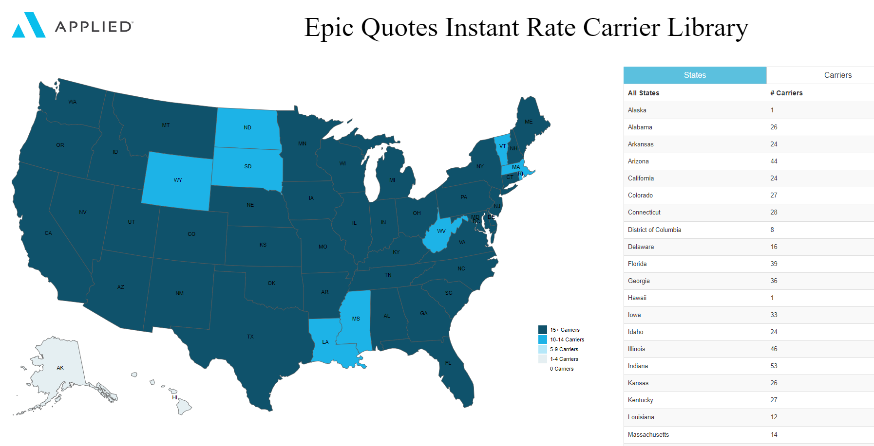

### One-Click Carrier Quoting (New Business)

1. For an **existing prospect or client**:
   1. Locate the Prospect or Client and click Quotes from the left panel
2. For a **new prospect or client**:
   1. Create a new Prospect or Client and complete the detail screen
   2. Click Continue to add additional contacts and contact information
   3. Click Quotes from the left panel
3. Complete the Quote information screen and click ADD

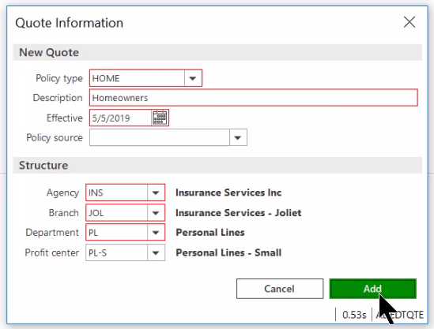

1. If licensed for the data prefill program, this screen will appear

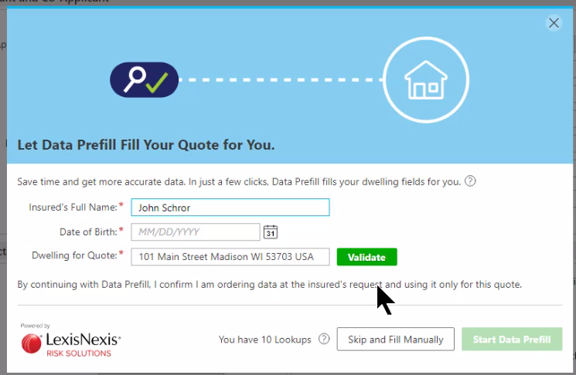

1. When moving from tab to tab, tabs having the required fields completed will turn green; a tab missing required fields will turn red

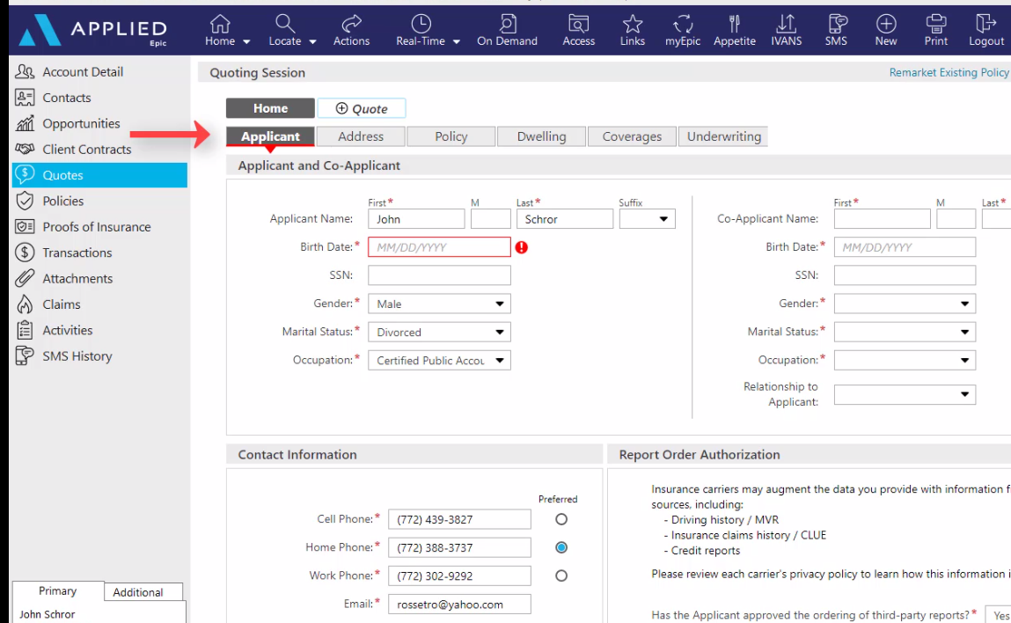

1. Fill in the missing required fields
2. Under the Address tab, if the address is not USPS validated, type the correct address, and click Validate

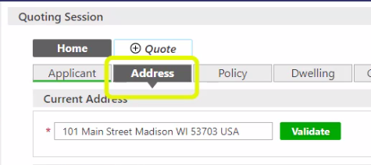

1. If still no match, use the Full Edit button to enter the address  
   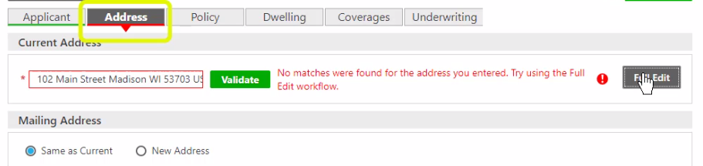
2. The Dwelling tab offers lots of options (i.e., Search Google, Find on Zillow, Visit Assessor, Distance to Coast, etc.) and you can change from map to satellite.

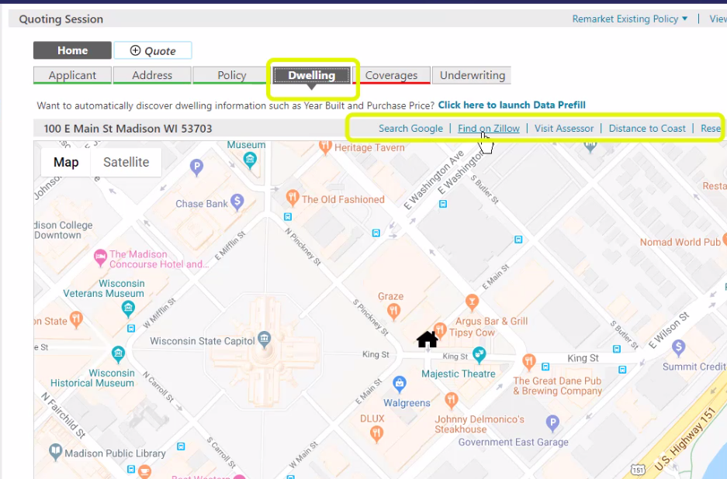

1. Enter information in all required fields under the Dwelling, Coverages, and Underwriting tabs.
2. If you are curious as to which carrier requires a specific field, hover your mouse over the asterisk and the carriers will be listed.

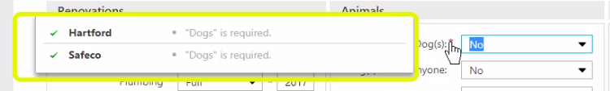

1. When all detail has been entered, click GET QUOTES

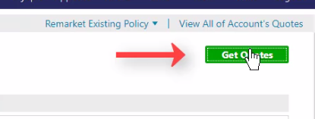

1. IVANS one-click or instant rate quotes will display automatically  
   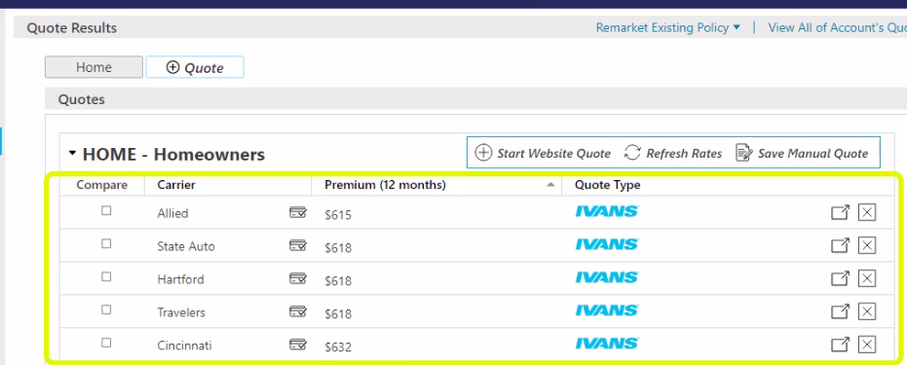
2. Chubb Masterpiece quotes are processed through Chubb (not IVANS). Select the “Get Rate” button to get into their desktop.



1. If additional required information is needed for a carrier, hover the mouse over the message to see which required fields are missing data. Clicking on the message will bring you back to the quote tabs.

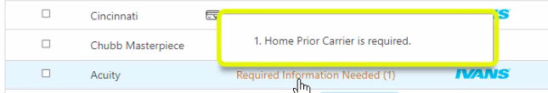

1. Enter the missing information and then click the Get Quotes button
2. The Agent ID button will appear if it’s the first time processing a quote with a carrier. Enter the ID number and click Get Rate. Enter your username and password for the carrier if prompted and select “Remember Credentials”



1. Review quote results. The little box with the checkmark indicates that a credit check was performed by the carrier

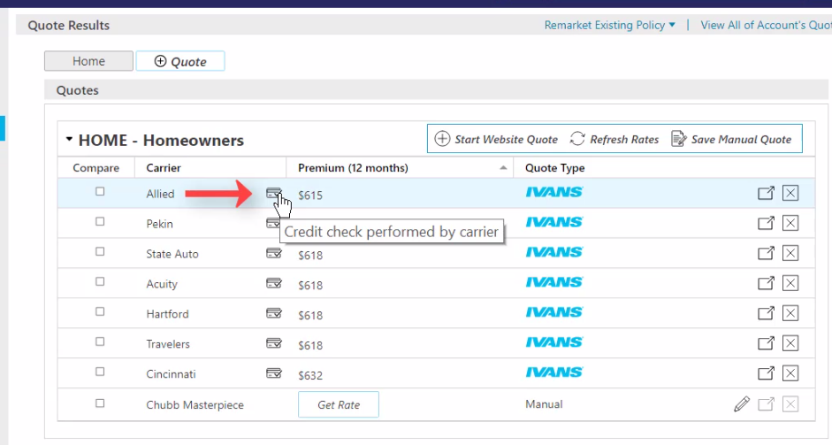

1. Return to the carrier’s website by clicking the arrow to the right.

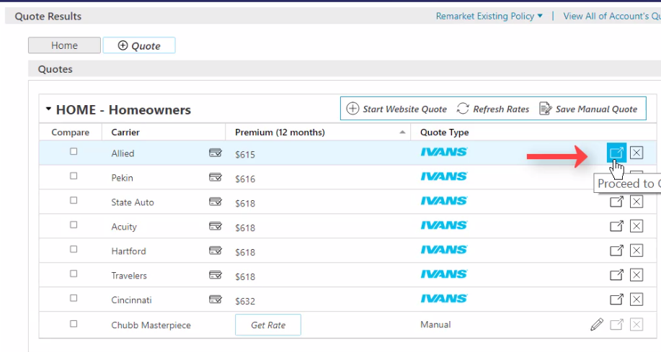

1. To quote with carriers not available via “One-Click,” see Live Fill workflow at the end of this section. If the carrier is not a “One Click” carrier or a “Live Fill” carrier, you can save a manual quote entering the detail yourself by clicking the “Save Manual Quote” button 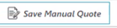

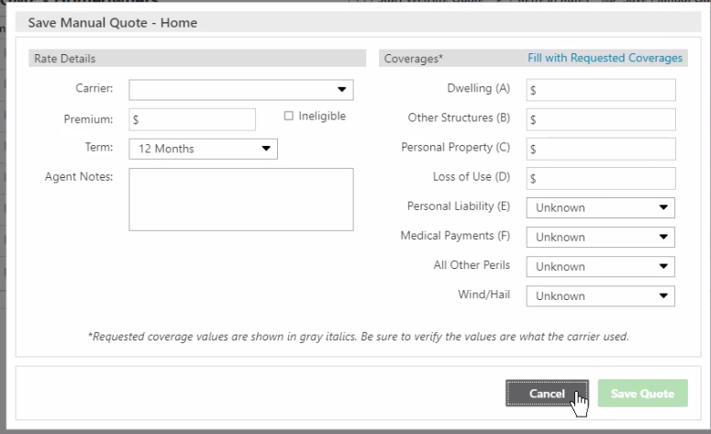

1. To compare quotes, check the boxes of the carriers you wish to compare and then click the “Compare” column header

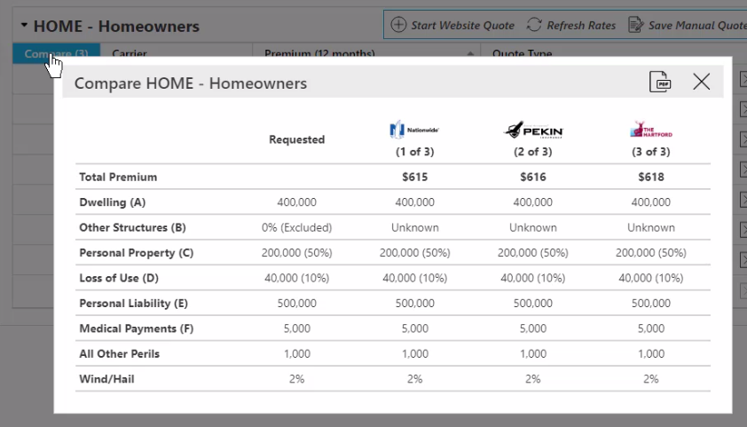

1. You can also generate a PDF to provide a comparison to the client.
2. To see the details of a quote, select it

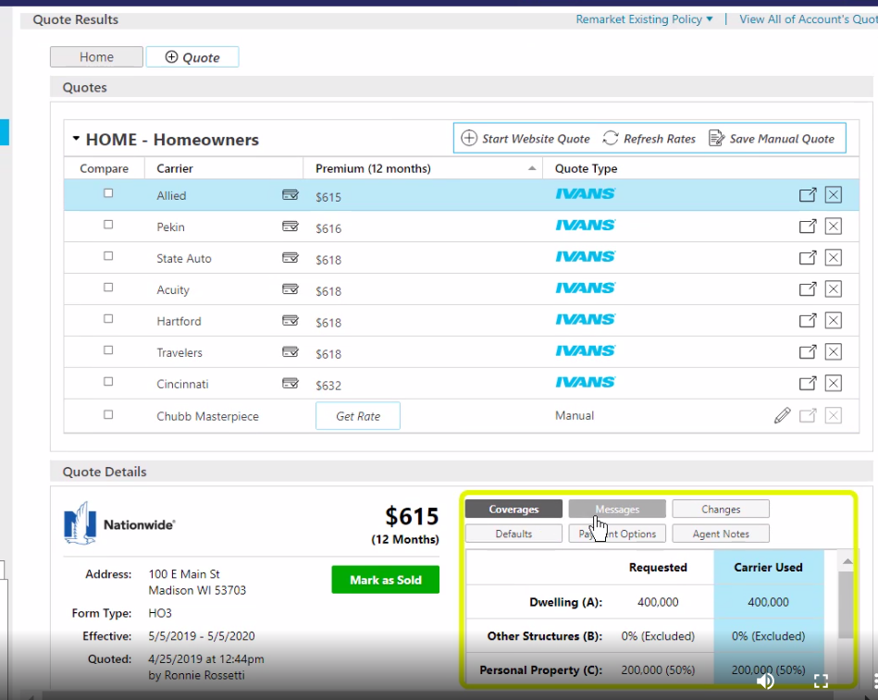

1. Click the buttons to see more detail

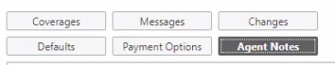

1. Once you’ve decided on a carrier, proceed to the carrier’s website by clicking the box with the arrow to the right and order the coverage to be bound.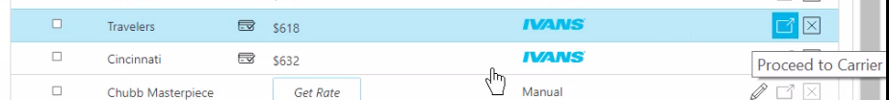
2. Click Mark as Sold and complete the “Accept Quotes” screen

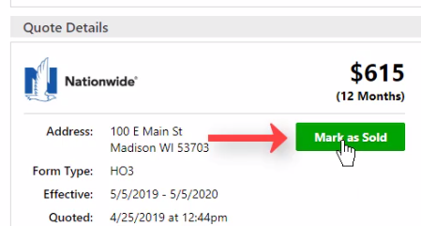  
  
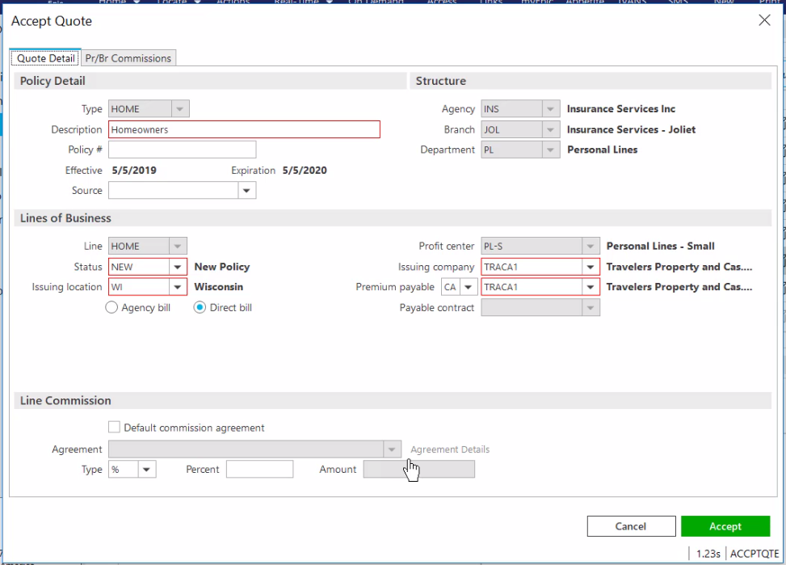

1. Don’t forget to add the PR/BR commission information under the PR/BR Commissions tab.

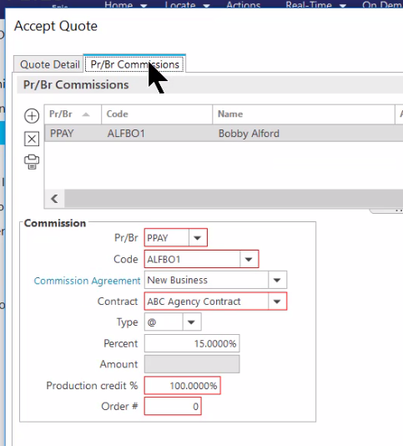

1. Once the Accept Quote screen is completed, click Accept at the bottom right and Epic will enter this quote as a **“submitted”** policy in the Policy area of the client’s account.
2. If the “Change Client Type” screen appears, click YES to update the policy to contracted and the prospect to client.
3. The quotes will be stored for history. The quote you selected will be marked as SOLD.
4. Download will update the service summary stage to “Issued” on the policy you created via Quotes.

### Quoting via Live Fill

1. To quote with carriers not available via one-click, click the “Start Website Quote” button. 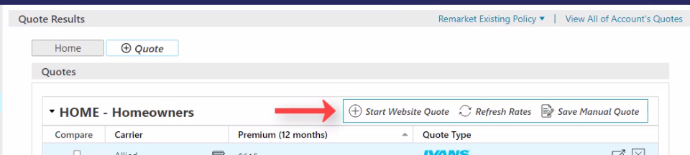
2. Click the drop down to see a list of all your appointed carriers and select a carrier

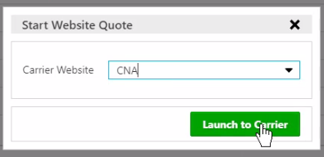

1. This will launch into the carrier’s quoting portal
2. Run your quote as would normally be done on the carrier’s portal
3. Epic will pre-fill all information entered in QUOTES. Information in data fields showing green or yellow came from Epic Quotes. Anything in white is a carrier-specific question.
4. The ability to change any of the prefilled data is there, if needed.
5. Once the quote is processed, it can be saved in the Quote Results page for a side-by-side comparison with other One-Click quotes.
6. Once finished with one carrier, close out of it, then select the next carrier from the drop-down list to repeat the process.
7. To save the quote, click the “Save Quote” button at the top right 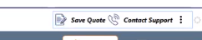
8. Enter information, then click Save Quote.

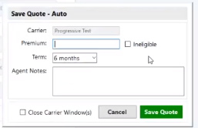

1. The quote will be saved on the “Quote Results” page, showing quote type as “Website”

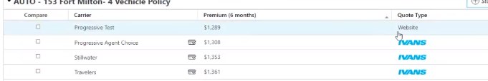

1. Click the boxes in the Compare column of the rates you wish to compare (including the website quotes) and then click the Compare column header to see the results.

### One-Click Carrier Quoting (Remarket Existing Policy)

1. If using Renewals Manager, highlight the expiring policy from there then click the Get Quote button.
2. If not, locate then select the client
3. Click Quotes in the left panel

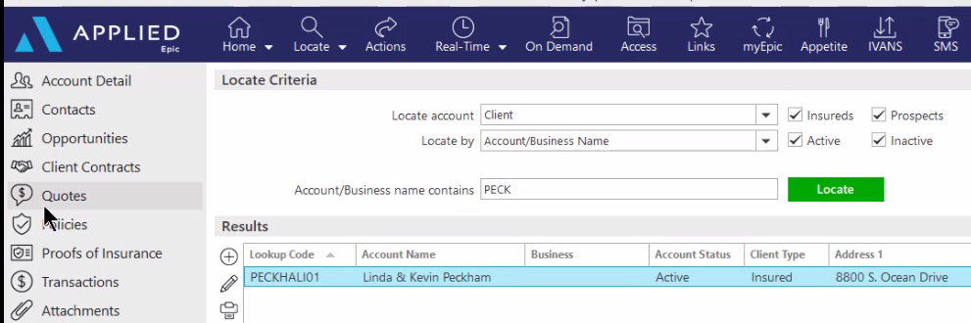

1. Cancel out of the new quotes screen. Instead click the link to “Remarket Existing Policy” at the top right

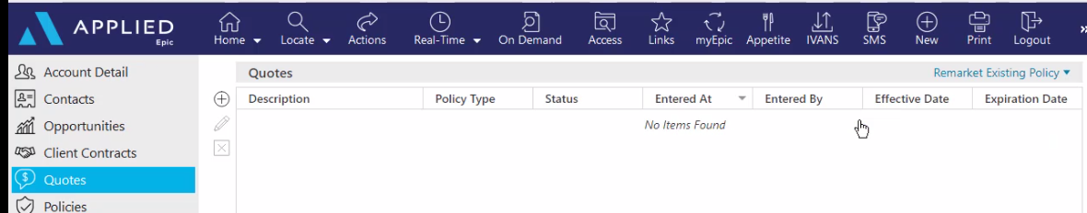

1. Select the policy to remarket
2. Complete the required information on Remarket Quote Information screen and select **ADD**

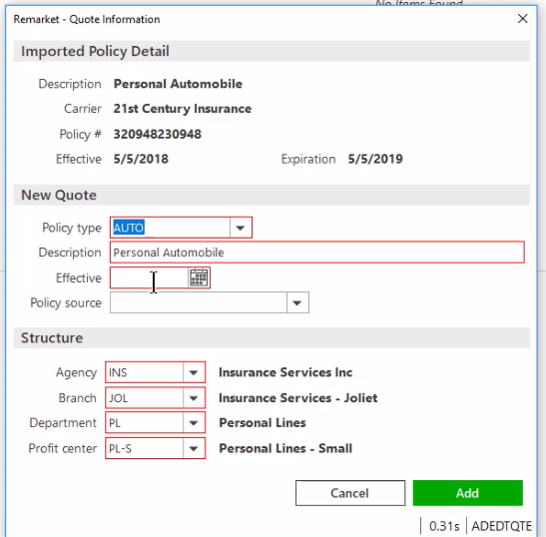

1. If licensed for the data prefill program, this screen will appear

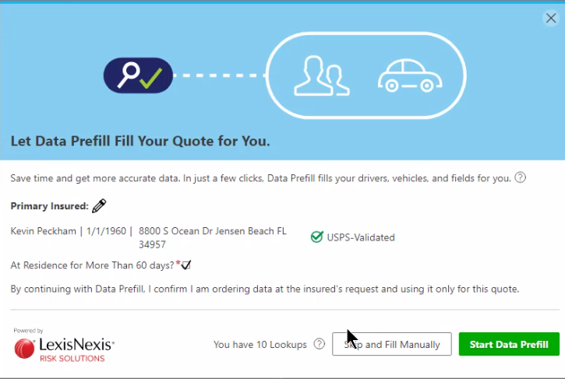

1. To view the information that came in from the existing policy, click the Summary tab  
   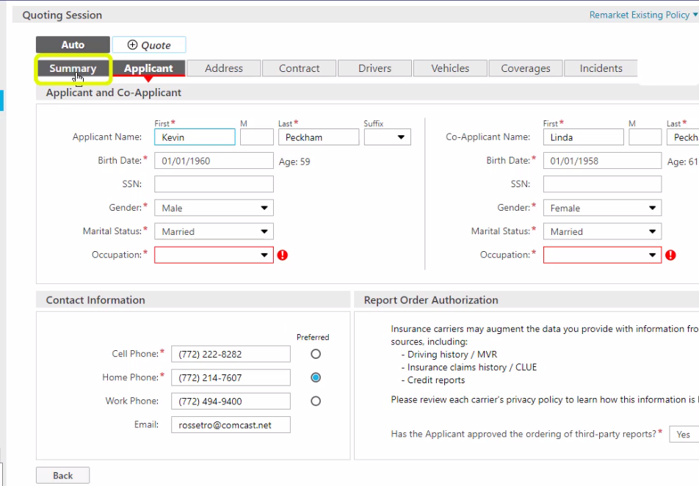
2. Go through each tab to see if there are any missing required fields.
3. Missing required fields will be in red, completed required fields will be in green. Enter the missing required information.
4. If another quote is needed for the insured, click the Add Quote button

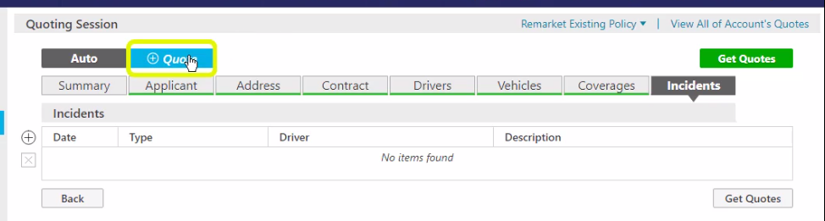

1. When all the fields have been completed, select Get Quotes

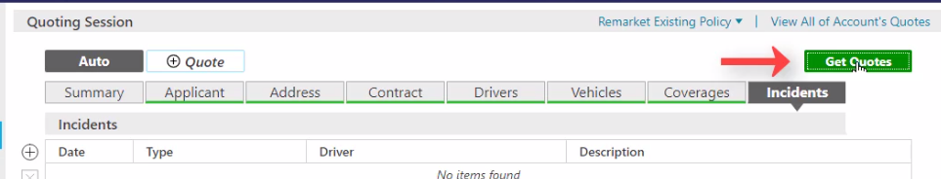

1. IVANS One-Click or Instant Rate Quotes display automatically
2. Highlight a quote to view details.
3. To compare several quotes, check the compare boxes, then click the Compare column header.
4. When a carrier is chosen, go to the carrier website, and order the coverage to be bound.
5. Mark as Sold
6. Complete the Accept Quote screen, including information in the PR/BR Commissions tab, then click the **Accept** button at the bottom right.
7. All the carriers and their quotes are retained for historical purposes.
8. If you go to the Policy area, you will note that the expiring policy renewed with the carrier you selected for binding and the service summary stage has been marked as Submitted. The download will update the stage to Issued.

## JA.2 Marketing Module Lite (New or Renewal Business)

### Add Master Marketing Submission

1. Click **Policies** area from the left Navigation Panel of the Client’s account
2. Change policy view from **Current** to **Marketed**



1. Click the ADD button (+)
2. Enter a name for the Submission (Name: 23-24 Master Submission)
3. Enter required information (Department & type of business)

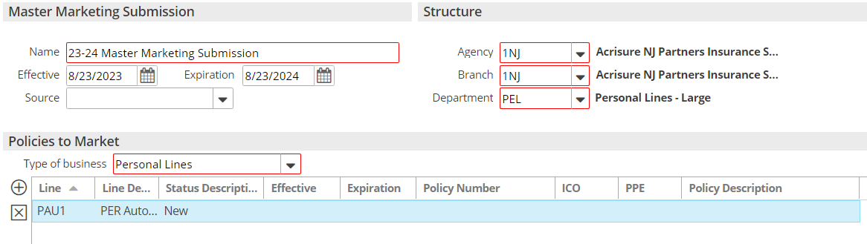

1. Add policies to the submission by clicking the **ADD** button under Policies to Market
2. **Add New Line**—Create new policy(ies) for marketing
3. Click DETAIL
4. Close the **AMMK** Activity - Finish
5. Enter policy detail by clicking each line in the navigation panel and completing each of the screens to fill in detail in the ACORD apps (be sure to add detail to the Personal AP/ACORD 88 first)
6. Click on Submission Detail area from the Navigation Panel and click the **ATTACHMENTS** Tab and drag & drop all attachments to be included in the submission

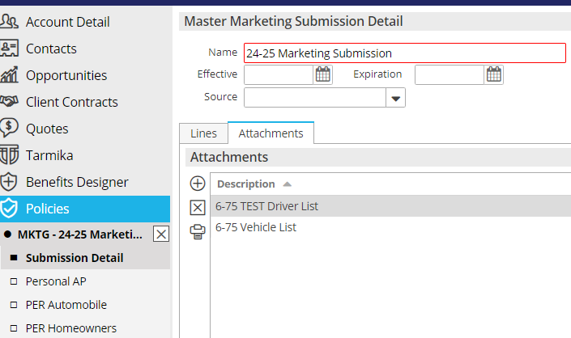

1. When finished, close Submission from the navigation panel (X)

### Add QNEW (New Business) or QREW (Renewal) Activity

1. From the **Policies Marketed** list view, highlight the Master Submission
2. Click the **NEW** button at the top in the blue bar; select **Activity** (or press F9)
3. Click **Continue**
4. Code = **QNEW or QREW**
5. Leave OPEN; add notes
6. Click **Finish**

### Send Applications to Carriers

#### Save & Submit ACORD Applications

1. Right click on the Master Marketing Submission created above
2. Select **Review Application**
3. Select the “Master Marketing Submission” radio button; click **Continue**
4. Click the **Organization Contact** tab and verify/update the agency address
5. Click the **Distribution** tab
6. Under **Delivery Options** select **“Attach Without Distributing”**
7. Click **Finish**
8. With the submission highlighted, click **ACCESS >** **Attachments**, **right click** on the ACORD, and select **Send Via Email** if emailing to the underwriter
9. If quoting online, add notes to the Open **QNEW** or **QREW** Activity.

#### Attach quote-related documents to QNEW or QREW

Be sure to attach all emails, documents, applications, etc. to **the QNEW or QREW activity**

1. Drag & drop onto the **QNEW** **or QREW** activity
2. Select the **Marketing** Folder
3. Click Finish on the **Attach to** screen

### Carrier Responses Received

1. Record carrier responses by adding NOTES in the **QNEW or QREW** activity.
   1. Right click on the **QNEW** **or QREW** activity
   2. Select Add Note
   3. Enter detailed note
   4. If carrier responded with a quote, enter the amount of the quote in the amount field on the activity. Use “Premium Quoted” as the amount qualifier.

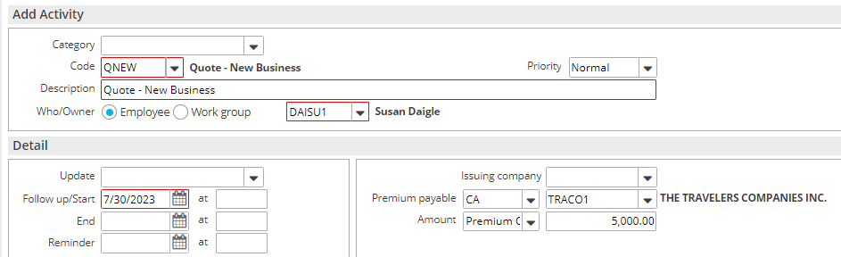

1. Drag & Drop Carrier emails to the **QNEW or QREW** Activity

### Carrier Selected for Binding

1. When a carrier is selected for **binding**, close the corresponding **QNEW** **or QREW** activity as **Successful** and add notes

***Please note, if no carrier is selected for Binding, close the corresponding QNEW or QREW as Unsuccessful and add notes. No further steps needed.***

#### Move Binding Carrier Submission to Current Policies

Follow these steps in order **- ONLY FOR THE SELECTED CARRIER:**

1. Right click the Master Submission and select **Create Carrier Submission**
   1. Premium Payable = select the binding carrier
   2. Submission Status = Completed
   3. Click Finish
2. Right click the Master Submission and select **Update Stage to Entered/Submitted**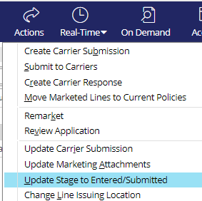
   * Click **Finish**
3. Right click the submission and select **Create Carrier Response**
   * Description = Quoted / Bound
   * Date Received = current date
   * Carrier Response = Quote
   * Enter Response Line Premium, carrier commission rate and click **Calculate**
   * Add Issuing company if known
   * Click **Finish**

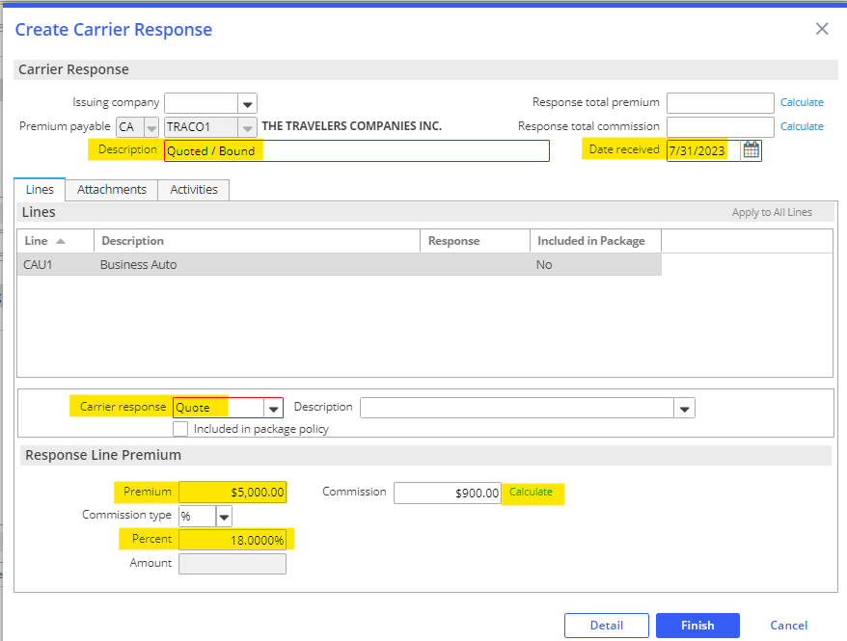

* + On the popup, select **Yes** Perform Action and select **Move Marketed Lines to Current Policies**

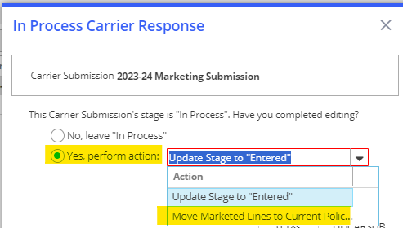

***Policies Tab****:*

1. Select **Add new Policy**
2. Enter Policy Line, Description, Effective & Expiration Dates
3. Update Stage to: Submitted or In Process if policy detail edits are needed
4. Select Contracted policy

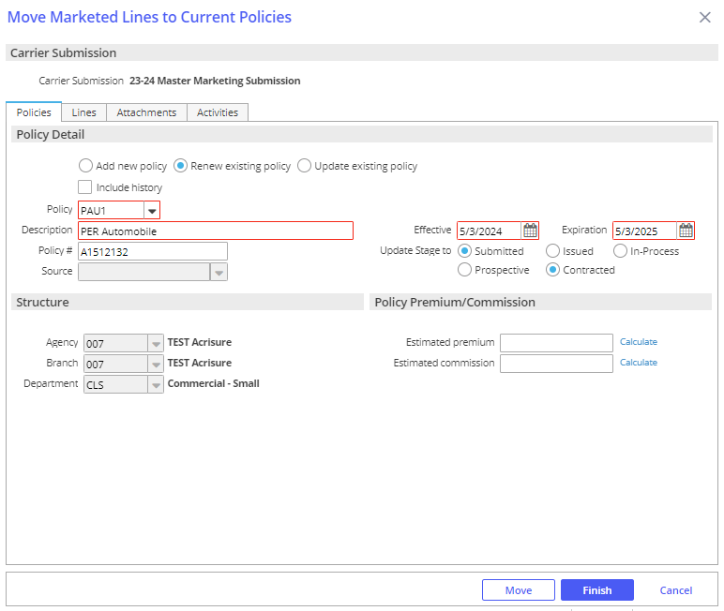

***Lines Tab:***

1. Select the lines you want to add to the new policy, renewal, or existing policy
2. Select **Add to this policy** - Adds the line to the policy added under the Policies tab

* Keep in mind that the choices are made here affect only the highlighted line
* Use **Apply to All Lines** if the choices apply to all lines and not just the highlighted line.

1. Under the LINE tab, select Status = NEW or REN; enter Issuing Co (writing co); enter carrier commission rate

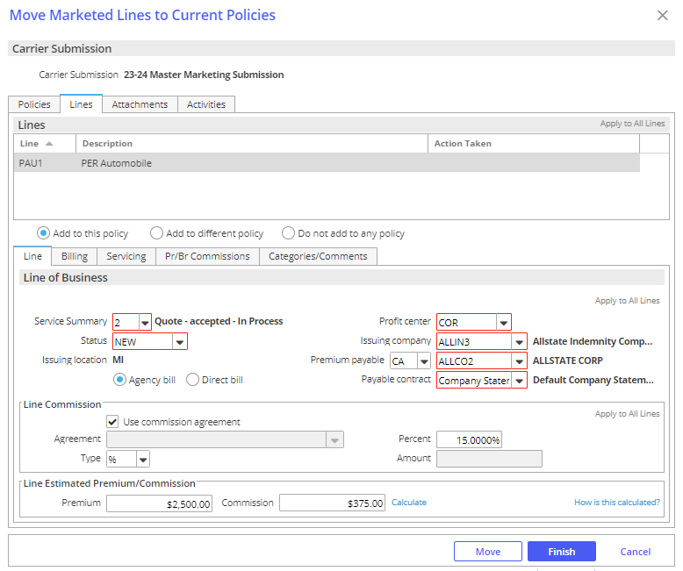

1. Click the **SERVICING** tab – verify the employees in each servicing role

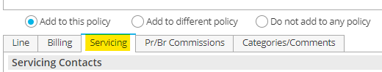

1. Click the **PR/BR COMMISSIONS** tab

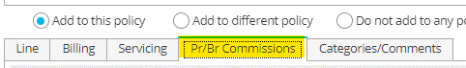

* + Click the ADD button to add the producer who will be paid commission on this policy if applicable
  + Producer Commission will default
  + Production credit should be 100%

1. When finished, click **MOVE**

* Update Submission status to Completed; click **Finish**

1. **BND1** Activity – Bind Policy via Master Marketing
   * Leave open for receipt of policy
   * Add Notes
2. Change Policy view from MARKETED to CURRENT

### Policy Received from Carrier

1. Drag & Drop the policy dec to the appropriate **Policy** in the client’s account
2. Issue the Policy in Epic:
   * Highlight the policy
   * Click **ACTIONS > Issue/Not Issue Policy** and **Issue**
   * Verify Policy #, Effective/Expiration Dates, Estimated Premium and Policy Status
   * Click the **Close Open Activities** tab and close the open **BND1** activity as Successful and add final note
   * Policy Check as directed by the platform
   * Click **FINISH**

## JA.3 Proofs of Insurance

### EPIC Auto ID Cards

1. Select Policy
2. **ACTIONS > Issue Auto ID Card**
3. Highlight the appropriate vehicle—make sure there’s a Y under the Issue Column or Click Select to Issue if not
4. Click the Distribution Tab
5. Select Contact (use magnifying glass to locate)
6. Select Via (Print, Email, Fax) and enter additional details
7. Click **Finish—AUID** Activity defaults closed

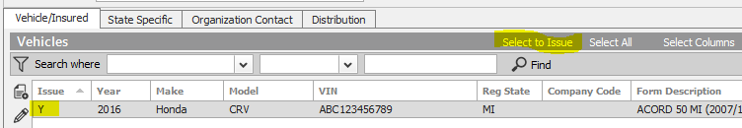

### EPIC Evidence of Property Insurance

#### Add New Evidence

1. Locate Account
2. Click the **NEW** button—Proofs > Evidence
3. Select the appropriate ACORD form; enter a Title
4. Under Type, select appropriate policy and service summary row
5. Click **Detail**
6. Click each section and enter details
7. When completed, click **ACTIONS** > **Issue Evidence**
8. Click the **Additional Interest Distribution Tab**
   * Select Contact (use magnifying glass to locate)
   * Select Via (Print, Email, Fax) and enter additional details
   * Click Finish
9. Click the X in the Navigation Panel to close the EPI

#### Renew Evidence

* + - 1. Locate Account
      2. Click Proofs of Insurance from the Navigation Panel
      3. Select Evidence
      4. Highlight the appropriate EPI
      5. Click **ACTIONS** > **Renew Evidence**
  + Select the renewal policy and service summary row
  + Select the lines of business to include
  + Check the defaults to include
  + Click Detail
    - 1. **Activity REVI** defaults closed—add notes, click Finish

#### Issue Single / New Additional Interest

* + - * 1. Locate Account
        2. Click Proofs of Insurance and select Evidence
        3. Click **ACCESS** > Activities—all activities
        4. Select the **REVI** Activity and review notes
        5. Click **ACCESS** **> Attachments** from the **REVI** Activity and review
        6. Click Proofs of Insurance and edit appropriate EPI
        7. Highlight the additional interest—click the **ADD** button to add new AI and detail
        8. Click **ACTIONS > Issue Singe Additional Interest**
        9. Uncheck Insured if not needed. Verify AI distribution.

Click **Finish**

## JA.4 Renewal Manager

### Renewal Stages

***Details in the Renewals Manager view are related to the expiring policy.***

|  |  |
| --- | --- |
| **Stage Description** | **How it functions** |
| **Renewal Not Started** | Tied to the Event: **Policy Created** (display policies with this stage in the RM "**0**" days after expiration) |
| **Pre-Renewal In-Process** | Manual - (display policies with this stage in the RM "**30**" days after expiration) |
| **Submitted For Quote** | Manual - (display policies with this stage in the RM "**30**" days after expiration) |
| **Quote Received** | Manual - (display policies with this stage in the RM to "**30**" days after expiration) |
| **Proposed** | Manual - (display policies with this stage in the RM to "**30**" days after expiration) |
| **Renewal In-Process** | Tied to the event: **Policy Renewed** (display policies with this stage in the RM "**30**" days after expiration) |
| **Renewed** | Manual - (display policies with this stage in the RM "**0**" days after expiration) |
| **Did Not Renew** | Tied to the event: **Policy Cancelled** (display policies with this stage in the RM "**0**" days after expiration) |

### Renewal Events

#### Policy Created

This Event is responsible for a new policy as well as a renewed policy to be given the Stage Renewal Not Started. This is the Stage that begins the renewal effort. Policies coming up for renewal will show in the RM, in advance of the renewal date with the Stage Renewal Not Started, according to the time frame assigned to the policy type.

* 150 days for commercial lines policy types
* 90 days for personal lines policy types
* 90 days for employee benefits policy types

#### Policy Renewed

This Event is tied to the Actions>Renew process. When the expiring policy (the current term…the one you are working on renewing) is renewed (via Actions>Renew), the expiring policy (i.e., the current term…the one you are working on renewing) will be given the Stage Renewal In-Process. The renewed policy (i.e., the policy created through the Actions>Renew process) will not show in the RM but will show in the Policy list view (e.g., Policies – Current/Renewed). The renewed policy will be given the Stage Renewal Not Started. This Stage should remain as is until you are ready to work on the renewal of that policy the following year. The renewed policy (i.e., the one created via Actions>Renew) will need to be Issued as normal. The Stage given to the expiring policy (i.e., the current term…the one you are working on renewing) will need to be changed, by the user, to Renewed once the renewal policy has been Issued. This Stage, Renewed, will be the final Stage given to the expiring policy in the RM. An expiring policy with the Stage Renewed will drop from the RM view on the expiration day.

#### Policy Cancelled

This Event is tied to the Actions>Cancel>Issued process. The Stage shown on a policy cancelled via the Actions>Cancel>Issued process will be Did Not Renew. Note: if the policy is reinstated, the Stage will automatically revert to the Stage it was assigned to before it was cancelled.

### Renewal Manager Workflows

#### View Renewals

1. From **HOME** screen select **Renewals Manager** from Navigation Bar

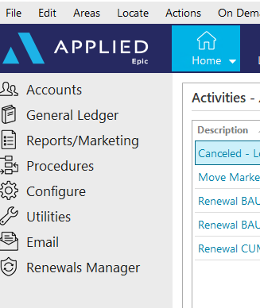

1. Assigned Servicers accounts will be displayed with a **Renewal Not Started** Renewal Stage

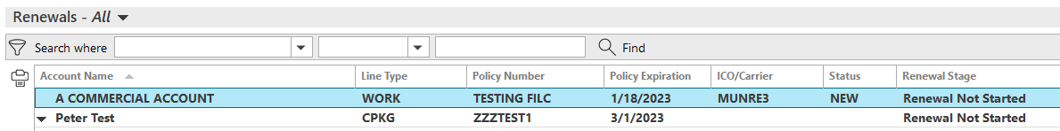

* **Personal Lines**: 90 Days prior to expiration
* **Commercial Lines**: 150 Days prior to expiration
* **Employee Benefits**: 90 Days prior to expiration

1. Click once on renewal to select:



* **Go to Policy** – Takes you directly into the policy under the client’s account
* **Renew** – Starts the renewal process from the client’s account
* **Marketing Submission** – Starts a marketing submission from the client’s account
* **Update Renewal Stage** – Allows you to manually update the renewal stage
* **Market Appetite** – Launches IVANS Market Appetite with list of possible markets

#### Renew Policy

1. Select **Renew** then refer to the **Renewal Process**/**Non-Downloaded Policies** section in your Workflows Document



1. Once renewal is started, the Renewal Stage will change to **Renewal in Process**
2. Manually update the stage as needed:

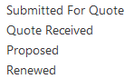

#### Marketing Submission

1. Select **Marketing Submission** then refer to the **Marketing Module** section in your Workflows Document



1. The Renewal Stage will NOT automatically update as you work through the Marketing Module. You must update the Renewal Stage manually by selecting **Update Renewal Stage.**



#### Cancelled/ Non-Renewed Policies

**Cancelled Policies:**

1. Refer to **Cancellations** section of your Workflows Document
2. Once **Cancellation** has been issued, the Renewals Manager Stage will automatically be updated to **DID NOT RENEW** and will drop off your Renewals Manger list

**Non-Renewed policies:**

1. Refer to **Policy Not Renewed** section of your Workflows Document
2. The Renewal Stage will NOT automatically update after you have Non-Renewed the Policy. You must update the Renewal Stage manually by selecting **DID NOT RENEW** from **Update Renewal Stage**. This policy will NOT drop off the Renewals Manager list, but will stay for one day AFTER expiration

## JA.5 DocuSign Integration

**From Attachments in the Client’s account**:

1. Right-click the attachment and select **Send to eSignature**

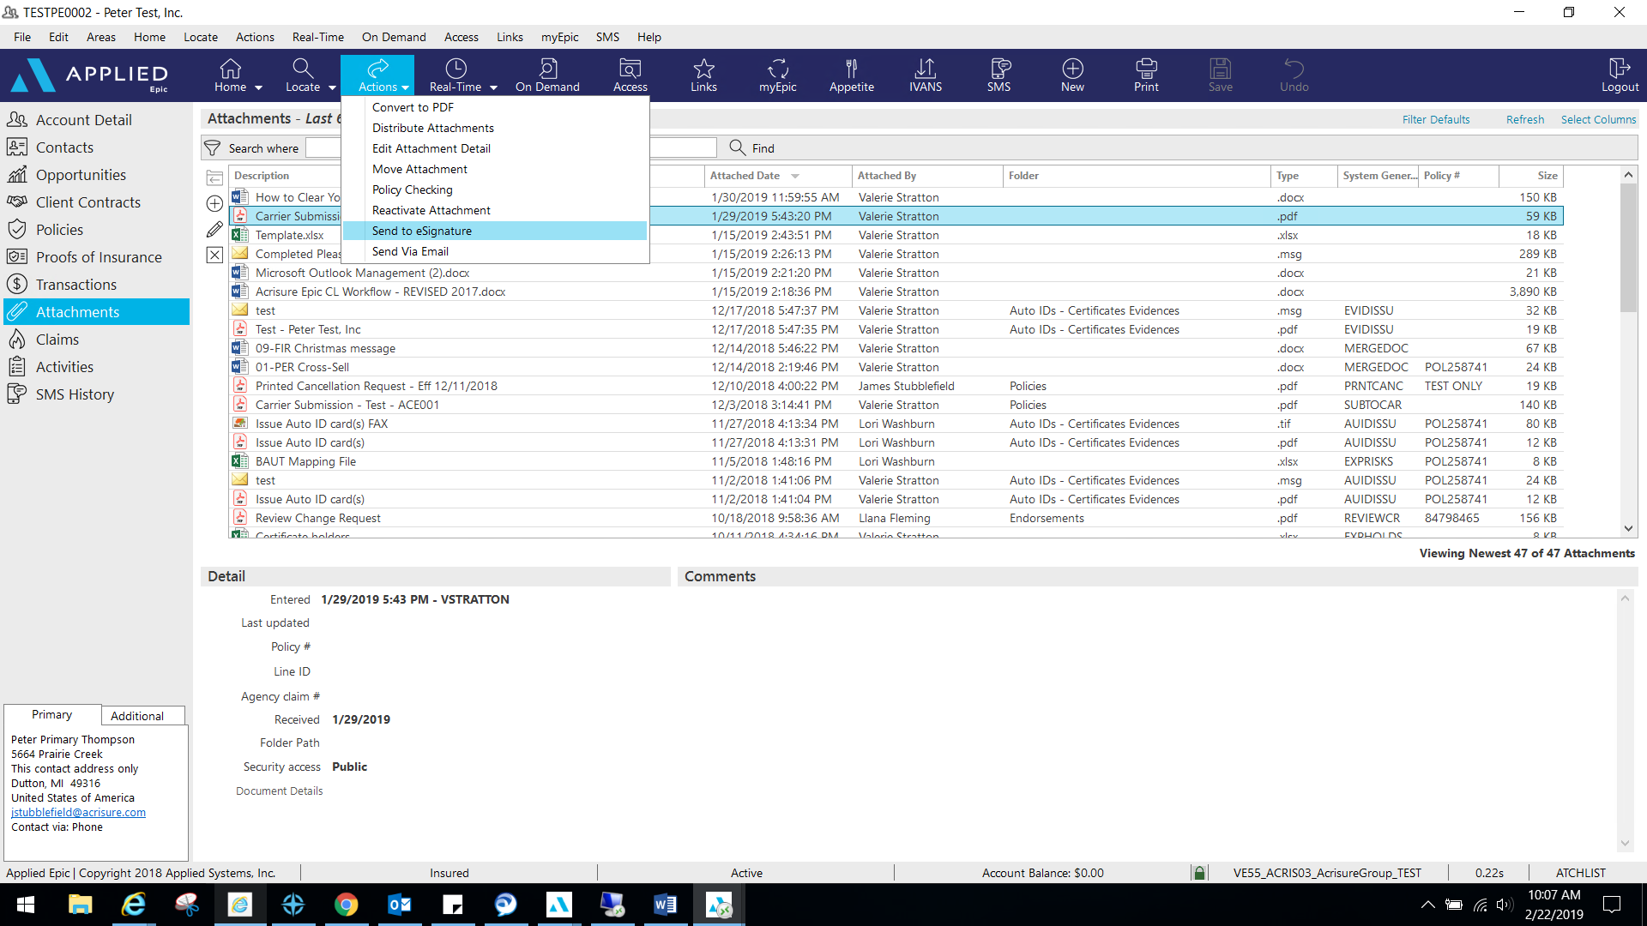

1. 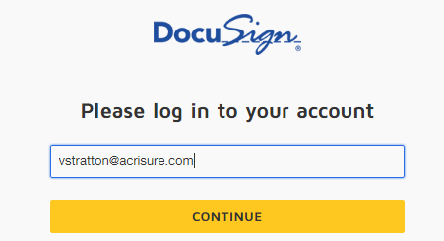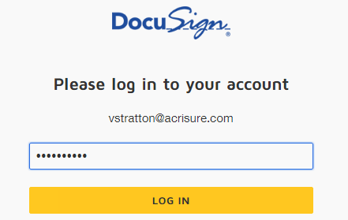Log into **DocuSign** using your email address and password.
2. Allow DocuSign permission to integrate with Epic.

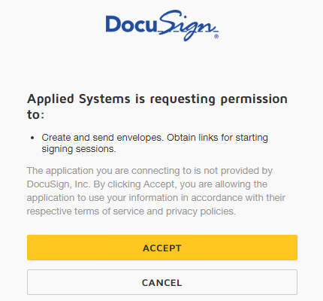

1. Select an Epic Contact; click the TO button

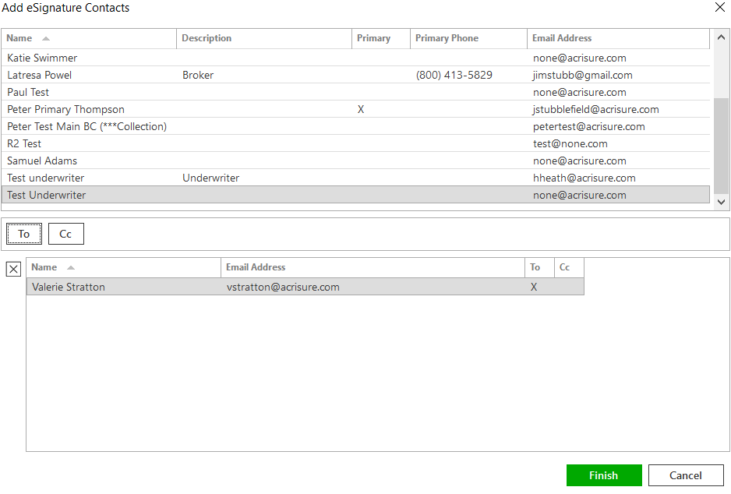

1. Please wait while Epic directs the document to DocuSign for signatures fields.
2. Add appropriate fields for signature, date, text, etc. by dragging and dropping onto the document.

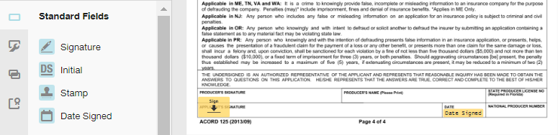

1. If you are using a template, you will need to remove the extra recipient. Actions>Edit Recipient.  
   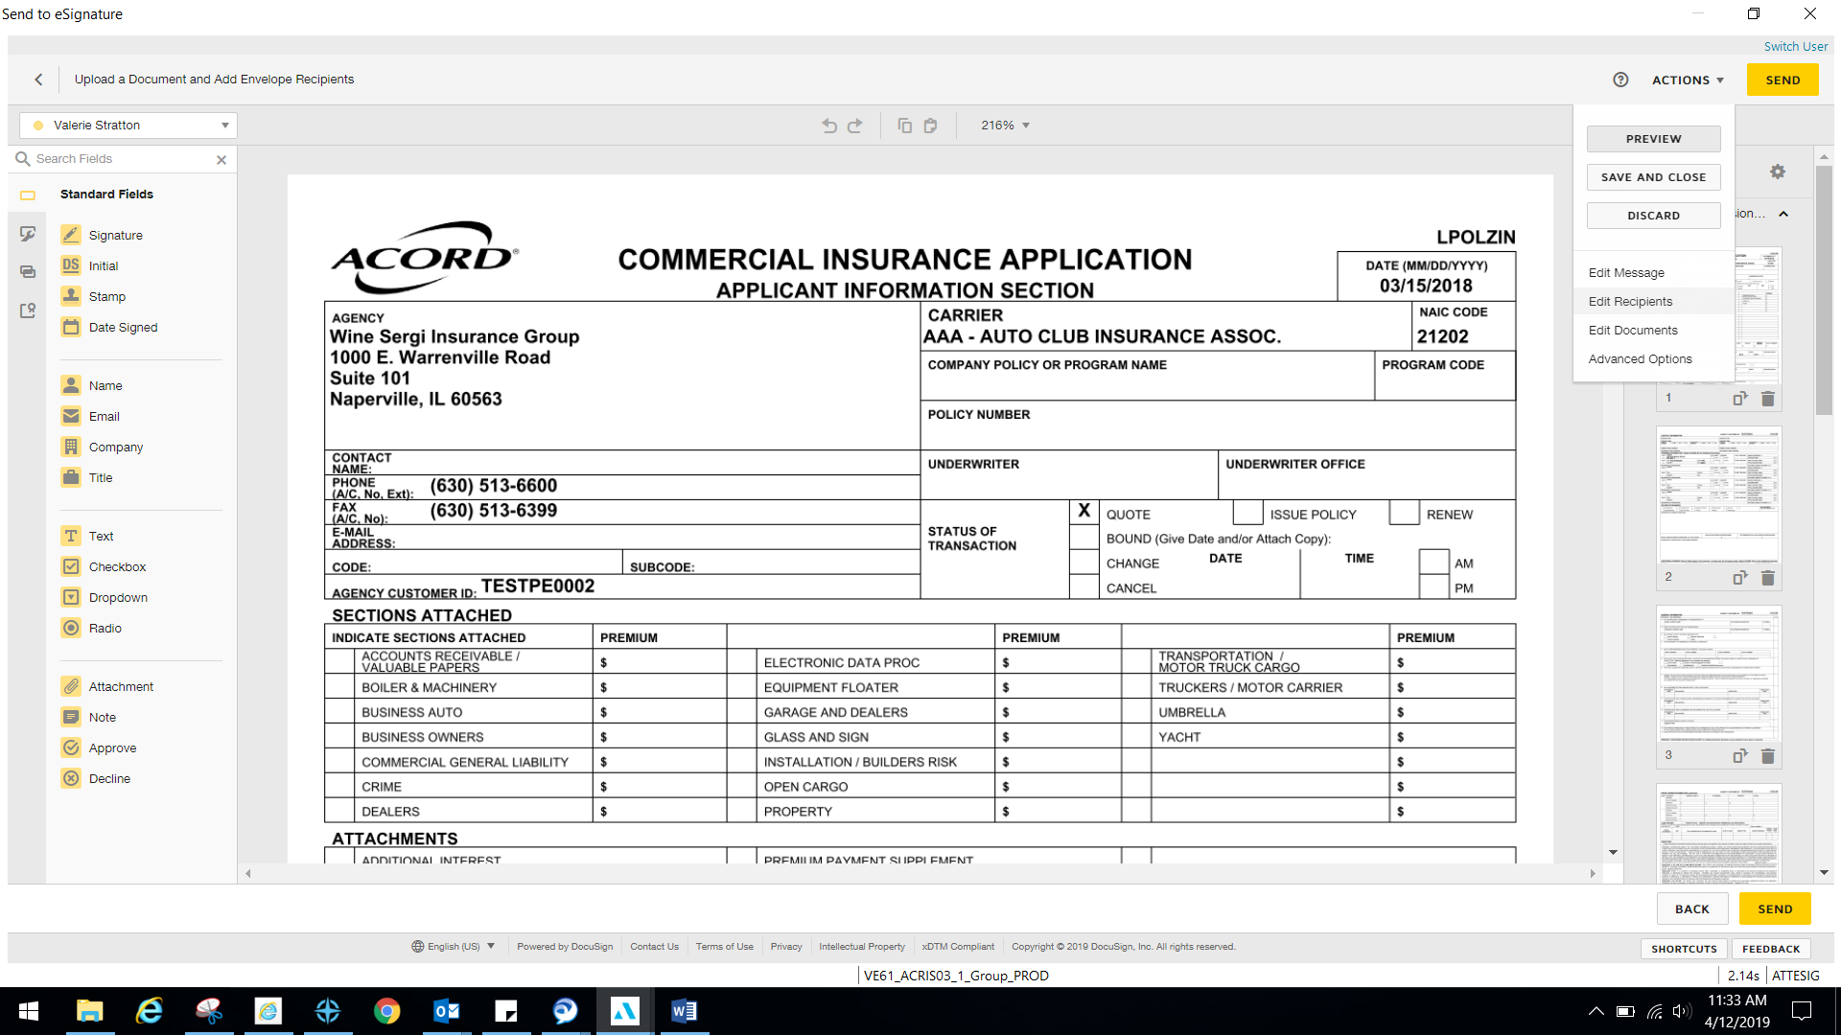
2. Once finished, select Actions>Edit Message.

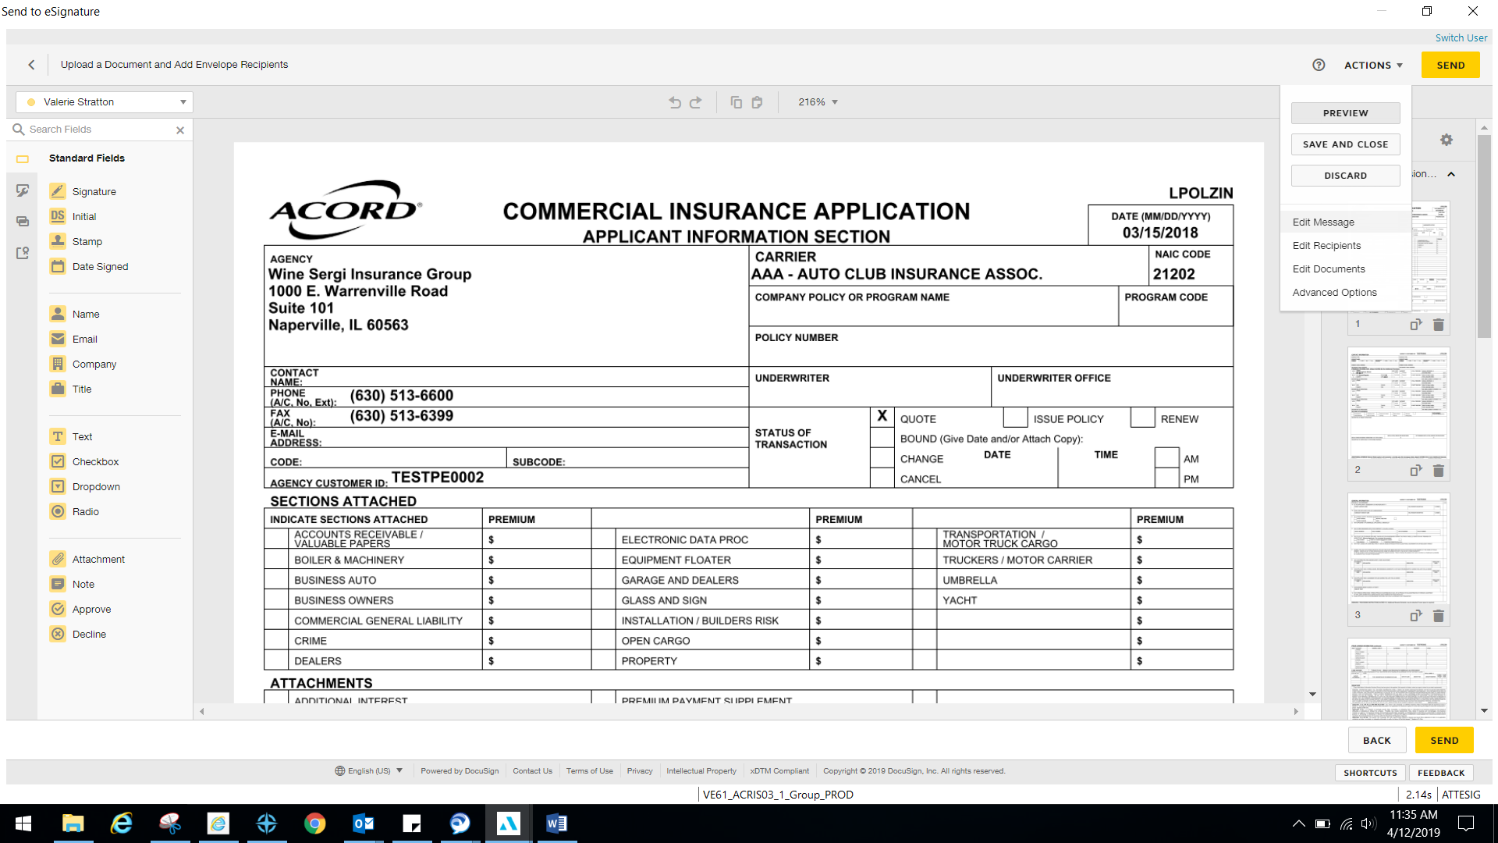

1. Edit the email subject line and personal message to client and select Done.

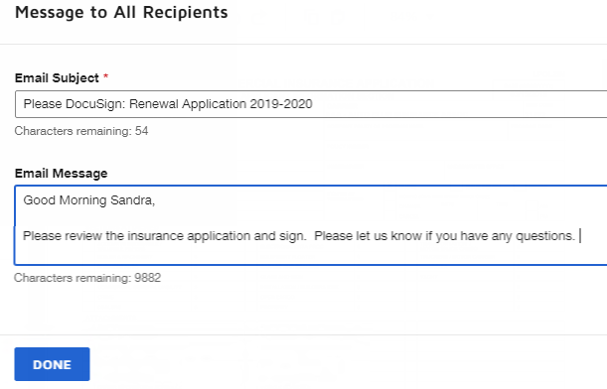

1. Select Send in the top right or bottom right corner when finished.

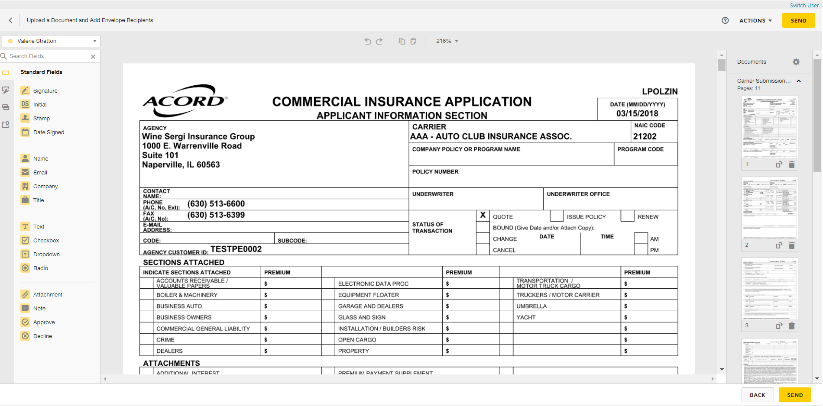

1. You will be redirected to your DocuSign account to manage your envelopes. Close out when finished.
2. **ESIG** will be the automatic activity generated once finished and will automatically remain open for follow up. Close **ESIG** as successful if there is another open activity related to this process.

## JA.6 Set Up CSR24 Portal from EPIC Contacts - Adding a Portal User

To set up a Contact as a Portal User:

1. Locate the Client’s Account in Epic
2. Click Contacts
3. Click Create Portal Account button

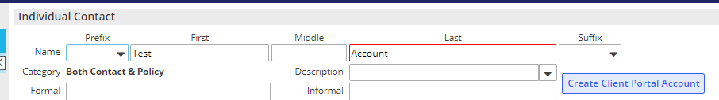

1. Click the Contact you wish to set up as the Portal User
2. In the top blue options bar, click Portal

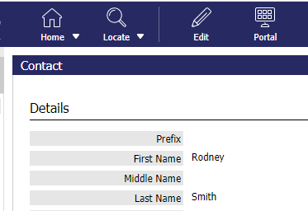

1. Username defaults to contact’s email address; change if necessary
2. Click the blue “Change Password” link and enter a temporary password

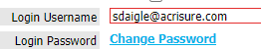

1. Check the box to Require User to change password on next login

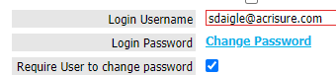

1. Select a Start Page to assign to this client contact (you will see your agency’s start page(s) in the dropdown list)
2. At the bottom of the screen, click this link

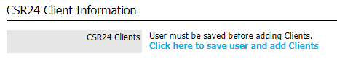

1. At the top of the screen, click the SAVE button



1. You will notice that back in the Contacts area, the Portal user box will be checked for the contact you just added.

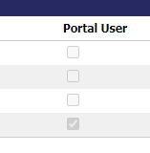

1. Repeat the process for any contact listed as needed.

## JA.7 CSR24 – Making Attachments Client Accessible

1. LOCATE Client
2. Click Attachments from the left navigation panel
3. Right click on the attachment you wish to give your client access to, and select **Edit Attachment Detail**

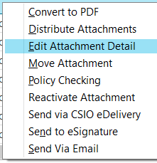

1. In the Attachment Details window:
   * Update the description as needed
   * Select the appropriate folder (select a folder only from this list)
   * Check the **Client Accessible** box
   * 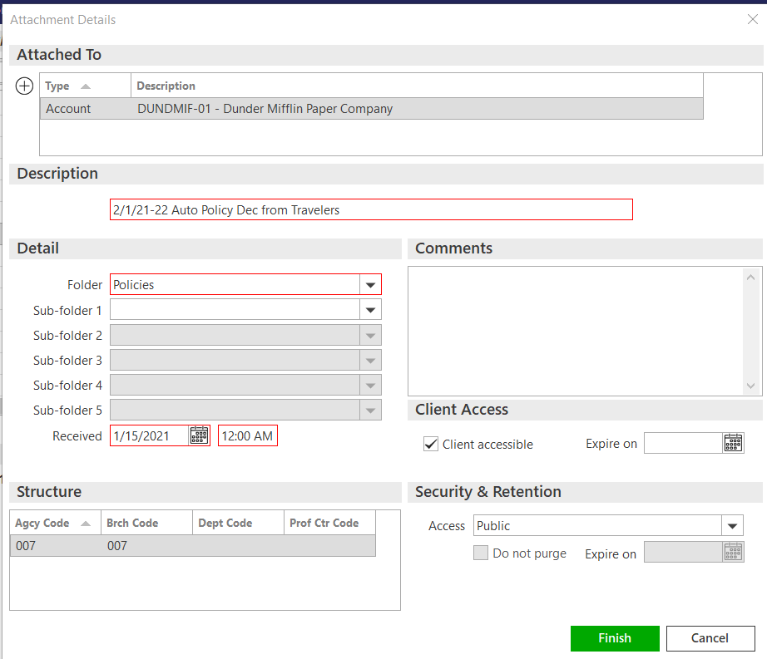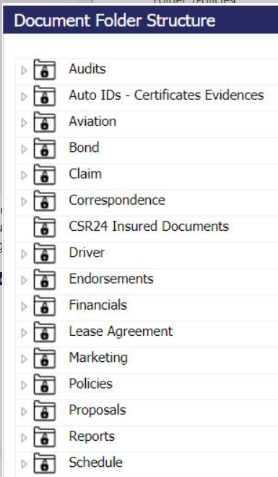Click FINISH

## JA. 9 Import and Export Risks

|  |
| --- |
| Import/Export can be performed for the following:   * Locations * Drivers * Named Insureds * Vehicles * Scheduled Equipment  STEP 1: Perform an Export to get an accurate mapping file  1. Highlight appropriate policy 2. Click **ACTIONS** > Export Risks 3. Select Type of Import 4. Select Mapping File 5. Enter a file name 6. Check “Disable Delivery Options” 7. Check “Send as Blank Template”      1. Click Continue 2. Click Export; Click **YES** 3. Click Attachments and locate the mapping file  STEP 2: Enter data on the Template Spreadsheet **Template file MUST remain as is. Do not delete any columns or the Import will not work.**   1. Copy and paste the information in each column. If there is no data for a particular column, leave it blank. 2. Click File > Save As and rename the Import File saving it to your Desktop  STEP 3: Import Policy status MUST be In Process in order to Import Risks. If the policy is not In Process, click **ACTIONS > Endorse/Revise Existing Lines** and choose the **CHGI** (Internal Policy Change) activity code. After the Import is complete, **ACTIONS** > Issue/Not Issue Endorsement and select Issue.   1. Highlight appropriate policy 2. Click ACTIONS > Import Risks 3. Click the ADD button to add the source file 4. Select Risk Type 5. Select an Importing Option:    1. Import & Update – items with no match will be added    2. Import & Replace – imported list will replace ALL existing items. Coverage information will be lost    3. Import, Update & Remove – items with no match will have the option to be deleted from the policy 6. Select File to Import – click the magnifying glass to locate the file you created in Step 2. 7. Choose “Existing File” if the file is located outside of Epic (i.e., Desktop); click Continue 8. Browse, select file, click Open 9. Change Description if needed 10. Click Finish 11. Click PROCESS      1. Pay attention to the **STATUS**; click Refresh. 2. When status = **Processed**, click CREATE 3. Pay attention to the STATUS; click Refresh 4. When status = **Created**, click PREVIEW 5. Import list will display 6. Click **IMPORT** 7. Click **YES** 8. Pay attention to Status; click Refresh 9. When import file disappears, the import was successful 10. Close window (red X top right) 11. Double click policy to view imported data 12. Close policy in Navigation Panel (gray X) 13. Select “Yes Perform Action” and choose “Issue/Not Issue Endorsement” 14. Click Finish  Import Errors   Epic will save a separate Excel file containing all the rows that failed.   1. Locate the Error File in Attachments 2. Fix the issues 3. File > Save As and save the updated file to your Desktop 4. Run the Import again |

## JA.10 Creating a Proposal or Summary in Epic

### General Information

|  |
| --- |
| Epic has been configured with templates to allow users to generate Platform branded Proposal and Summary that can be used to present to clients when marketing coverage for new or renewal business. The Summary template is accessed using On Demand>Proposal – Do not use On Demand>Summary of Insurance.    **The following are highlights and pointers to consider:**   * The same proposal group works from either the Current/Future lines or the Marketed lines (at the carrier response stage) * Each line of business is configured to pull the following four (4) areas from the Epic policy details into the Line of Business page on the Proposal:   + Additional Coverages   + Forms & Endorsements   + Remarks (only when the Print on form is checked)   + Additional Interest * When using the Summary Group, users will have to associate the Line of business to both the Premium Summary pages and the Detail pages for each selected policy. This will ensure that the policies will appear on the premium summary page as well as the policy detail pages.      * Remember to enable Macros when the Word document generates as this is how the data merges into the document. * The overall formatting of each page of the Proposal and Summary templates has been designed to meet the legal specifications of Acrisure and to meet general needs of most of the users. The word document will need to be reviewed carefully as some data may need to be manually updated. Tables and data fields with no information should be updated or deleted and spacing should be adjusted to provide a professional look and feel. |

### How to Generate a Proposal

|  |
| --- |
| 1. Within the Client Account navigate to the Policies tab.  2. Click on a policy (or package header)   * 1. If creating a proposal for Marketed, change the view from Current/Renew to Marketed and then select the Submission.   3. On the Option Bar/Menu (top navy bar) click On Demand>Proposal.  **Refer to the screen shot below and the corresponding numbers with the following steps:**    See Notes  1. Add/Remove the policies that will need to be included in the proposal.   * 1. Click on the ADD button and choose from either:   2. the available current/renewed policies, if generating from the current/renew policies view   3. the available lines being in the marketing submission, if generating from the marketing area   * You do not need to reposition the LOBs on the top half of the proposal box.  2. Pick the Proposal Group. The NJ Platform has the following options and each one has preselected pages within the group. Choose the option that best suits your needs.   * 1. 1. Acrisure Standard Proposal   2. 1. CL Acrisure Summary of Insurance   3. 1. PL Acrisure Summary of Insurance   3. The Proposal Templates/Proposal Documents box will display all the preselected pages available based on the selected Proposal Group. This list must be reviewed, and pages deleted or rearranged based on guidelines determined by your leadership.   * 1. You must have a cover page and it must be in the top position   2. Associate a Line of Business to the Location Summary page to pull premises data   4. Individual Contacts are from the Account Contacts tab and will default with the Primary contact. added here will pull through to the Authorized Persons page.  **Notes:**  1. Before pressing Finish, you can add/move/delete pages, using the buttons on the left.  2. If you have multiple LOB of the same type, extras will drop to the bottom of the list. Be sure to reorder them before pressing Finish.  3. The premium summary page must appear after all the LOBs. Note: after merging, it can be moved.  4. LOBs without an associated Line will be suppressed by default. Uncheck the box next to Suppress blank templates to bring in the page even if there is not a LOB connected yet (e.g. you want to offer Cyber but it is not included on your account yet). |